**Hadoop Concept**

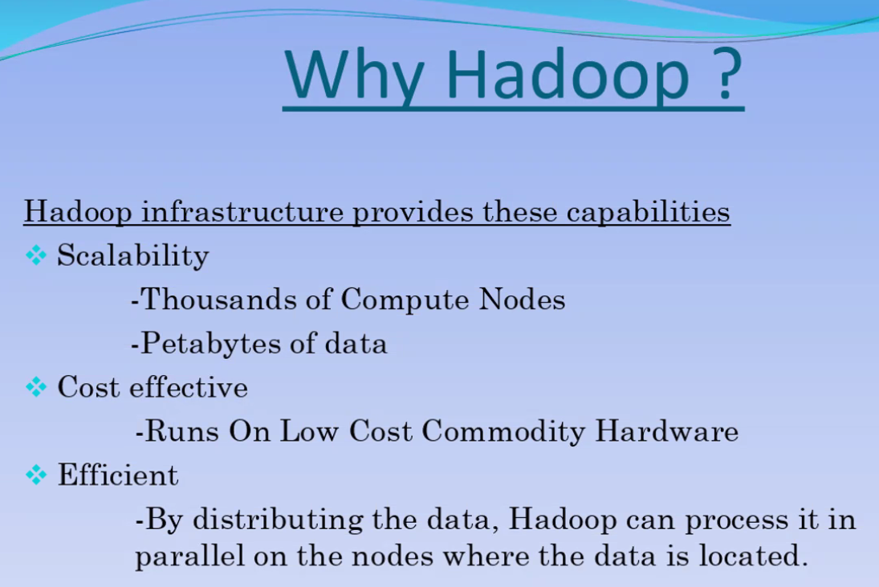

Structure of data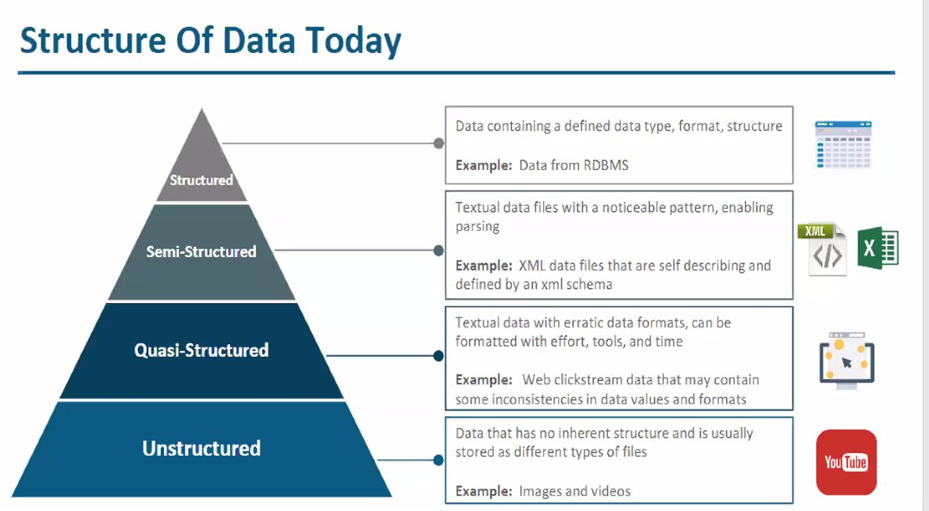

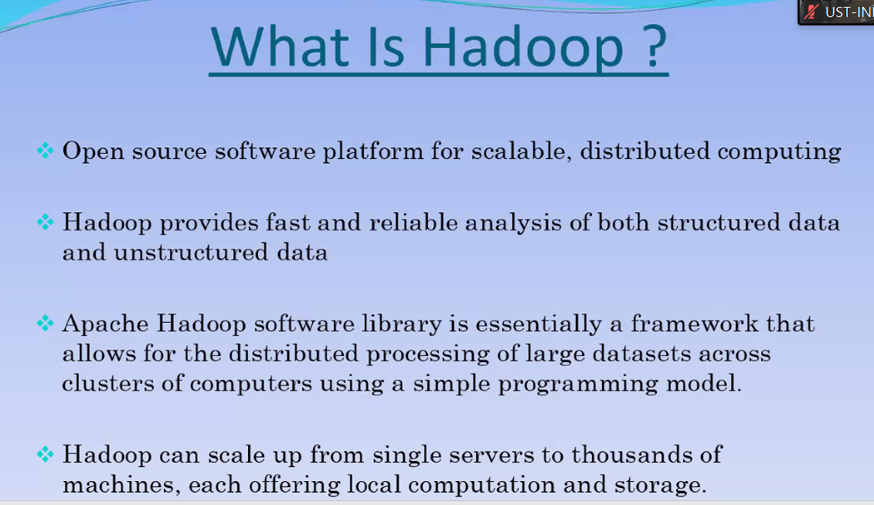

HDFS – Hadoop distributed file system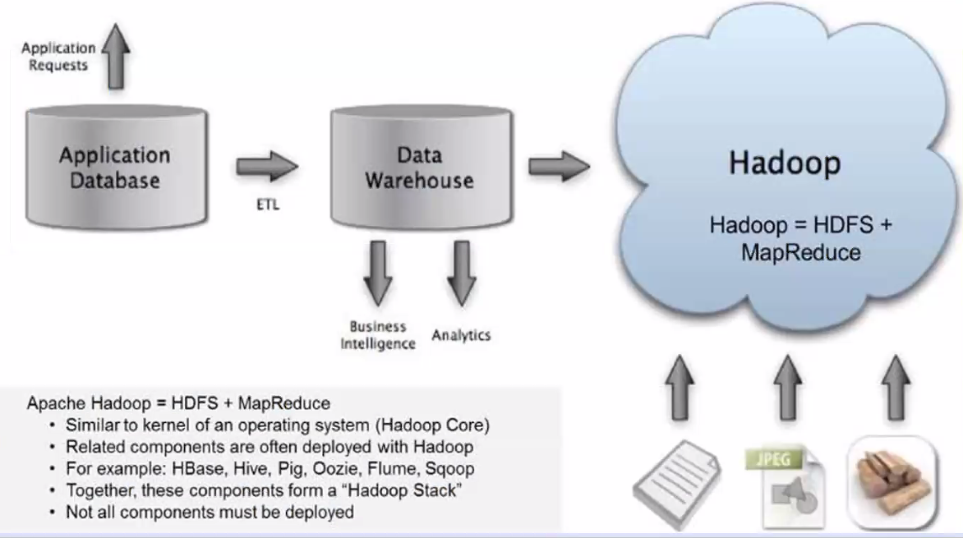

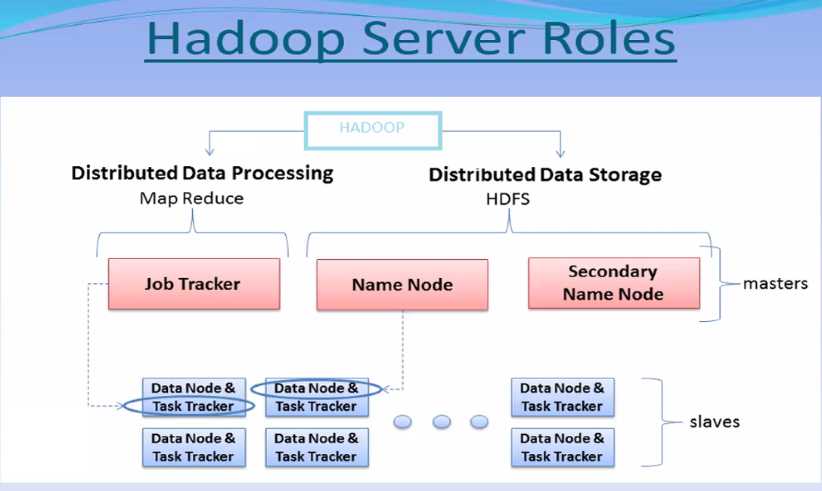

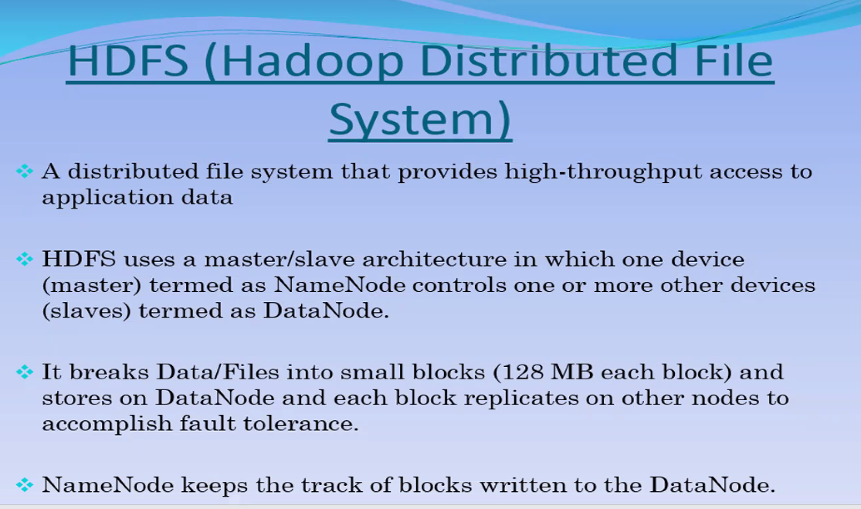

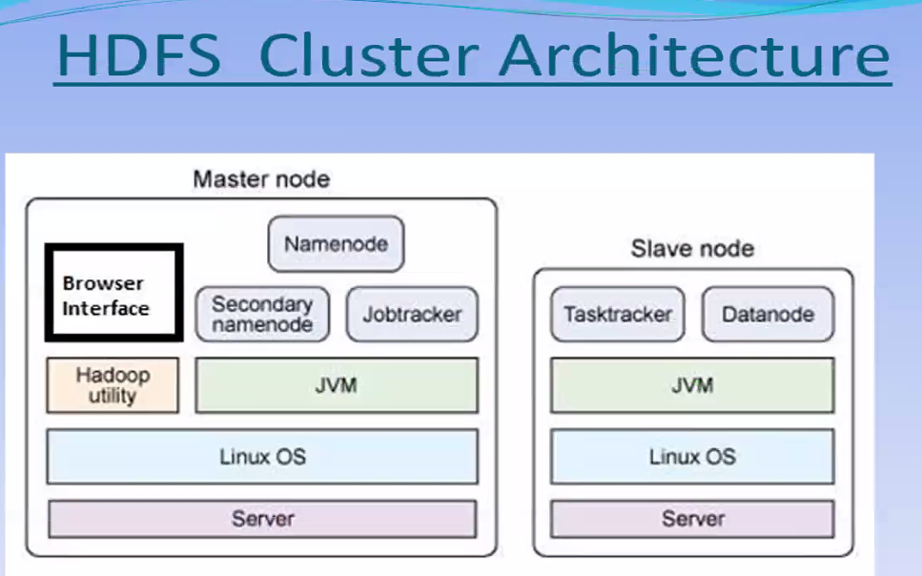

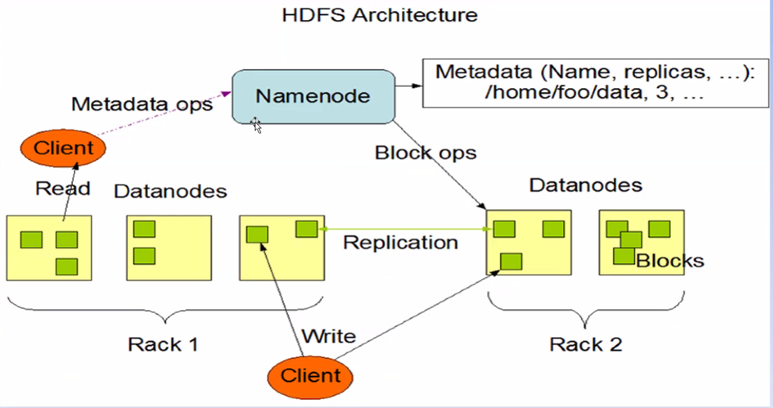

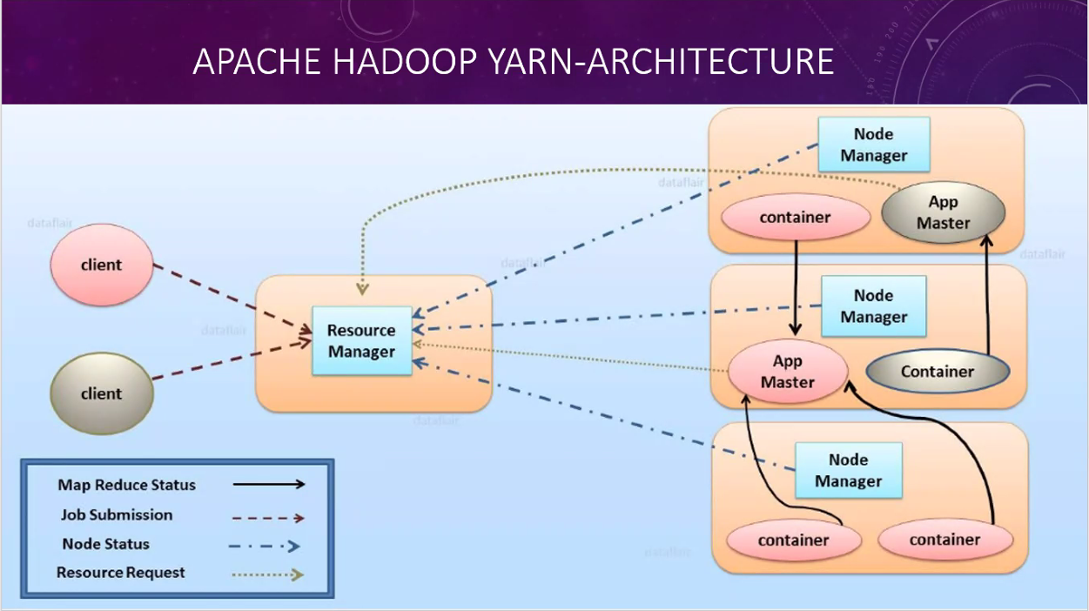

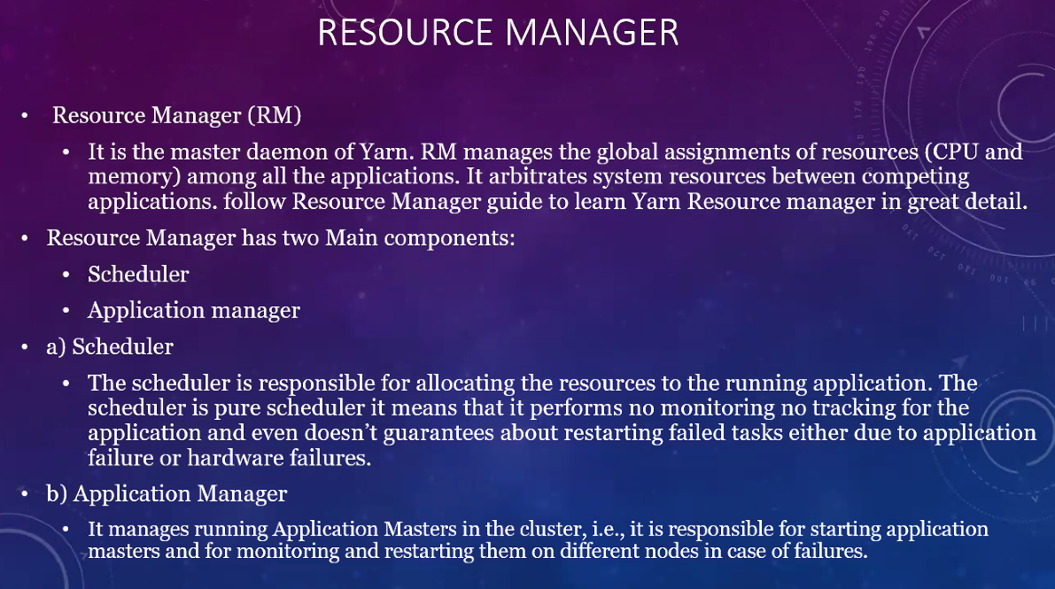

Namr Node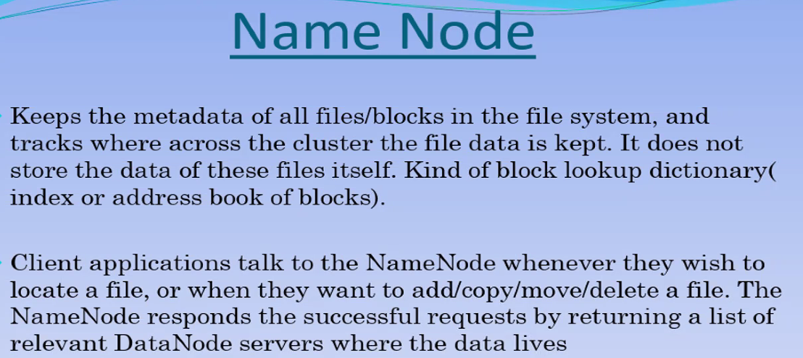

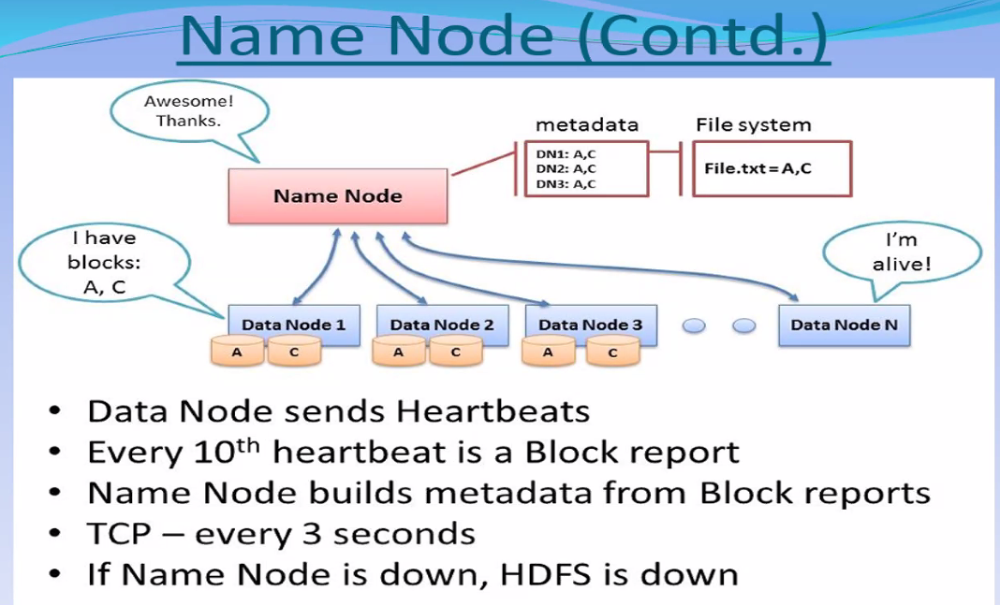

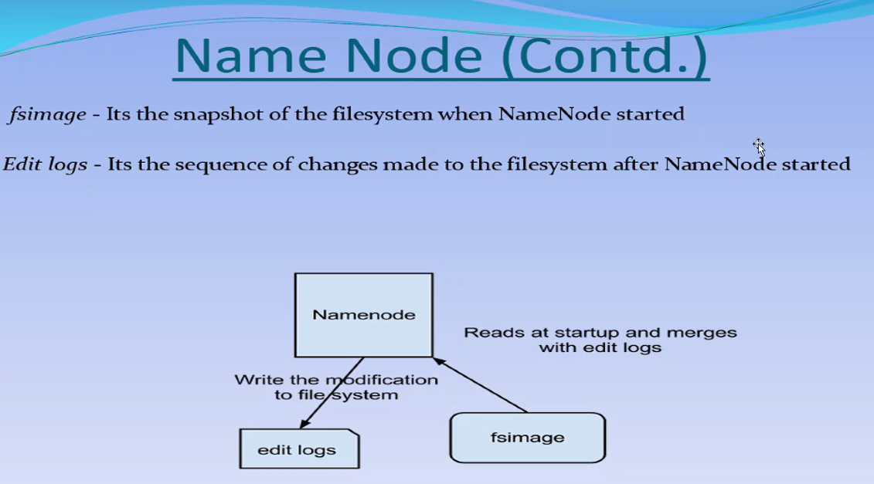

Data node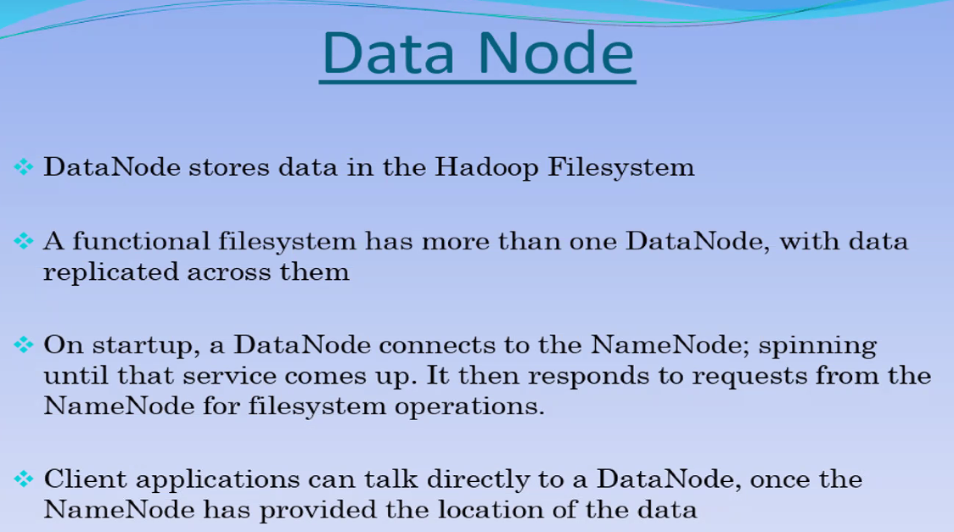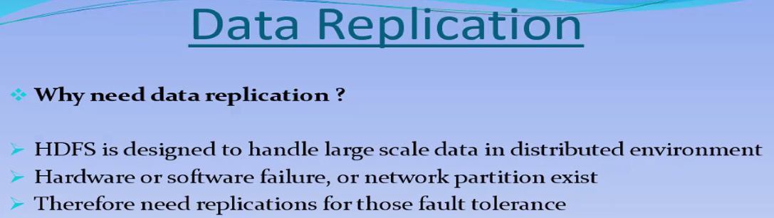

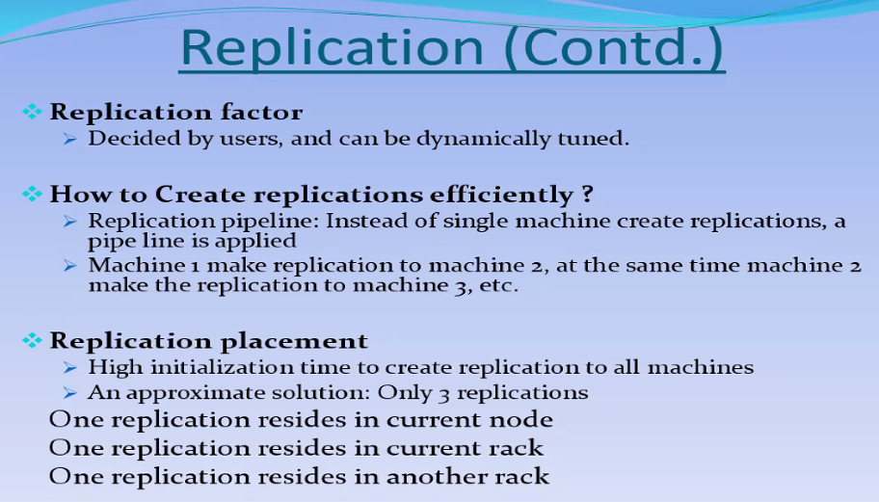

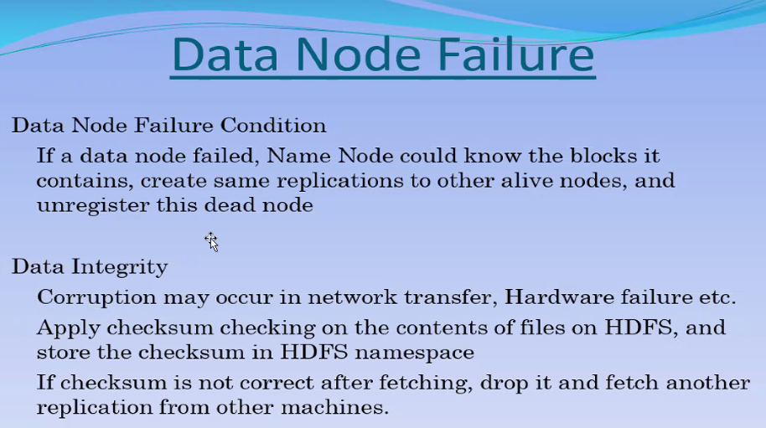

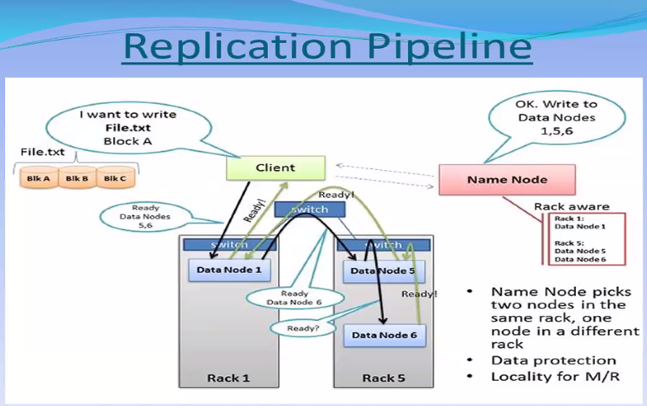

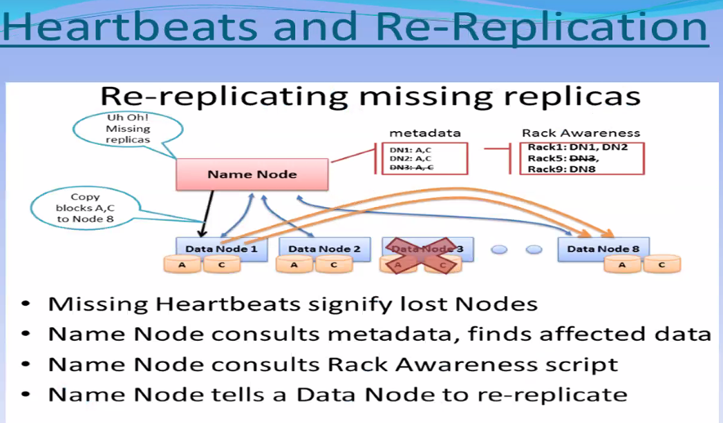

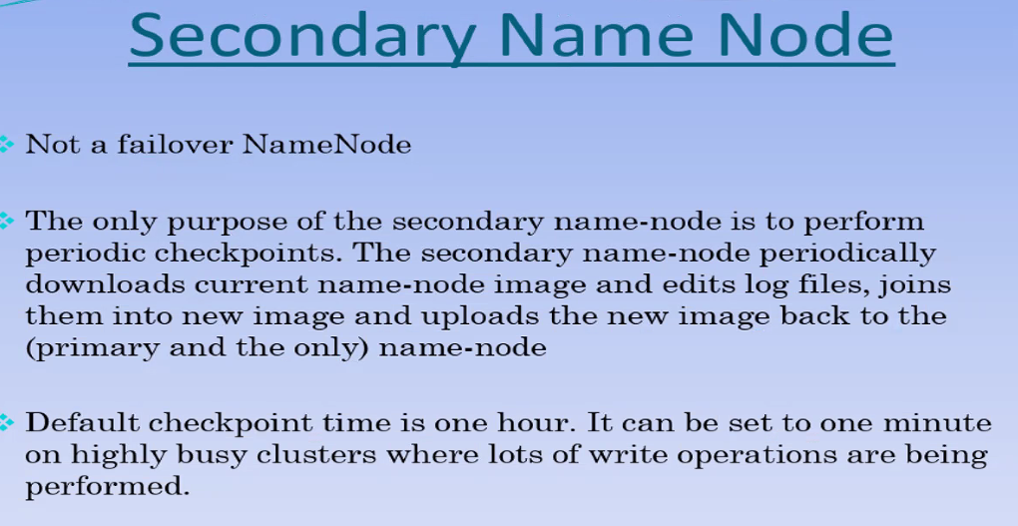

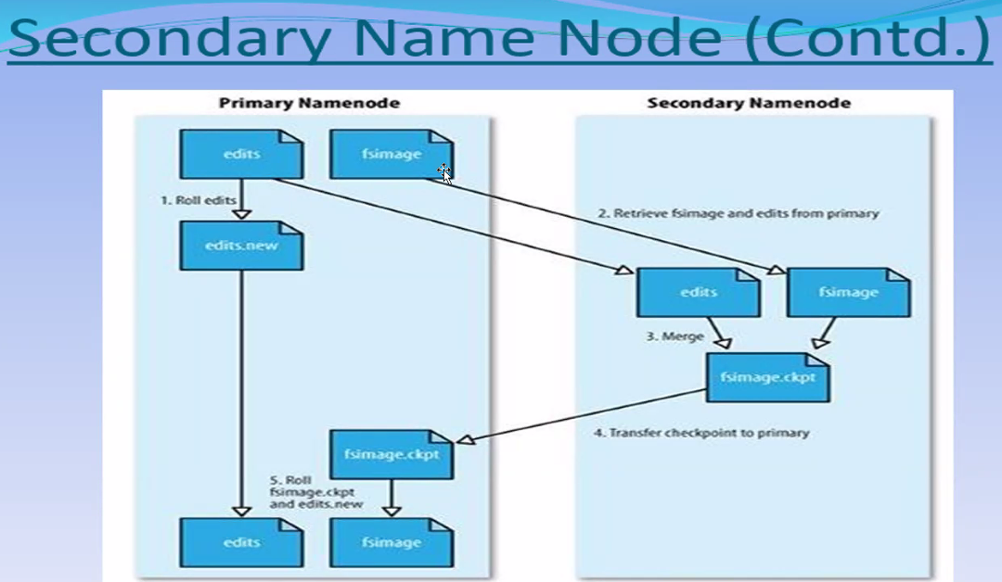

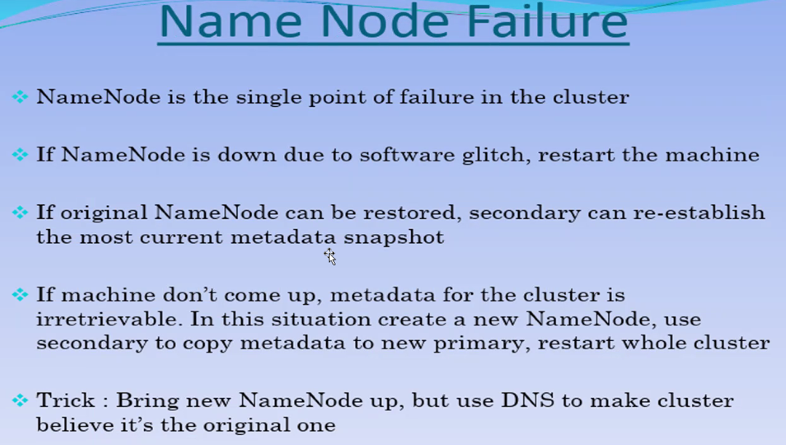

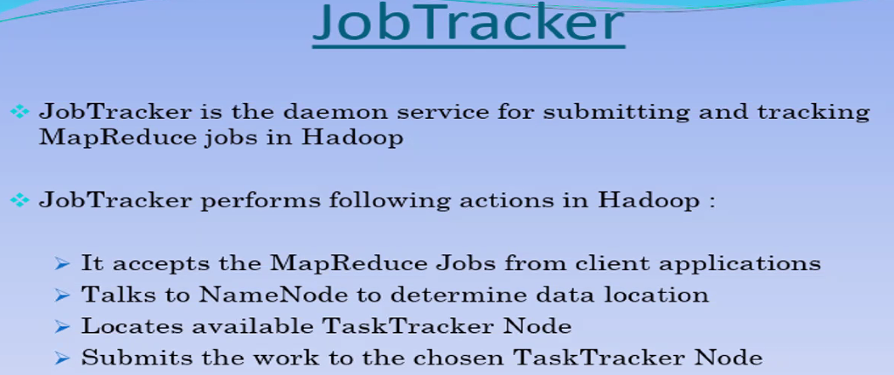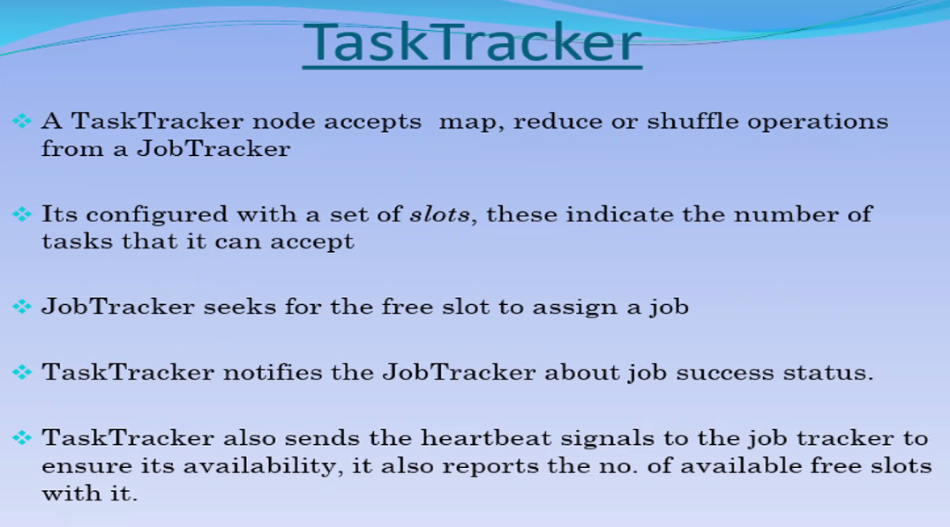

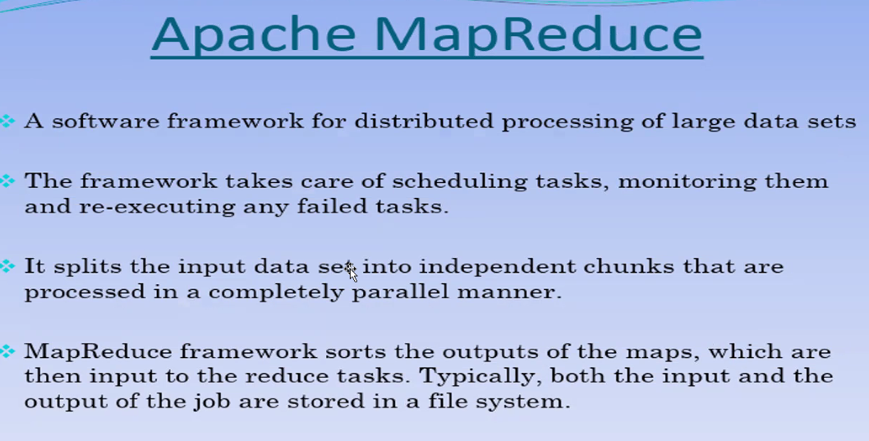

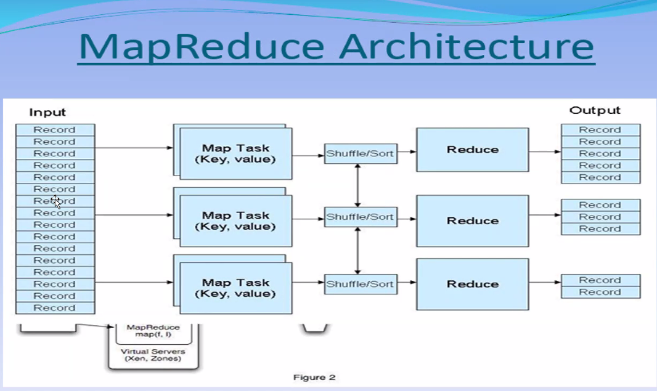

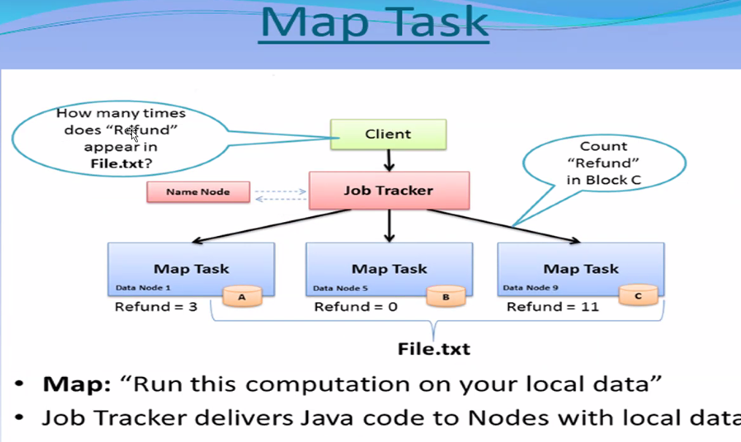

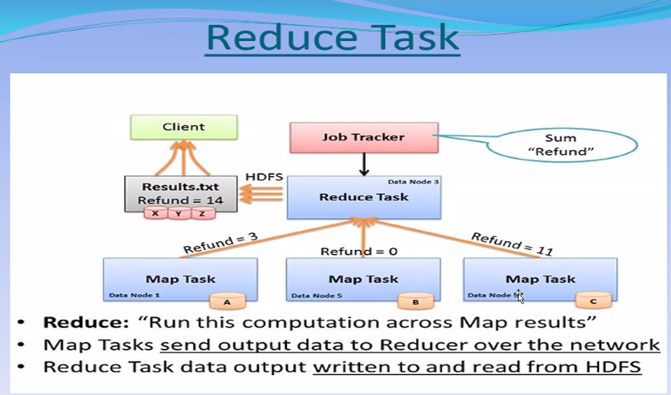

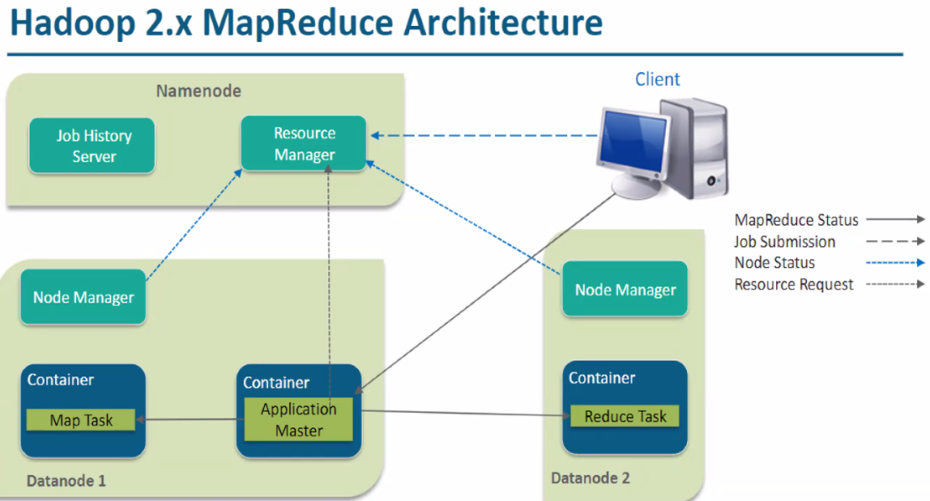

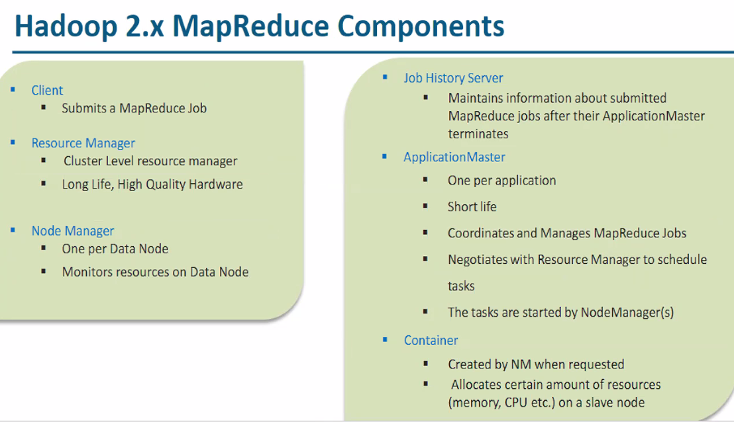

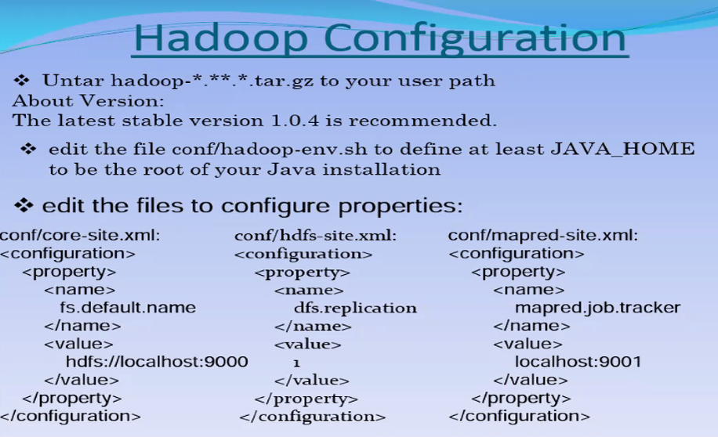

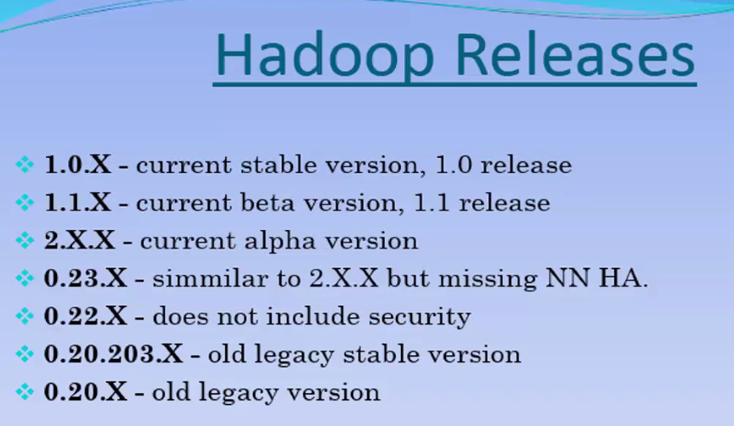

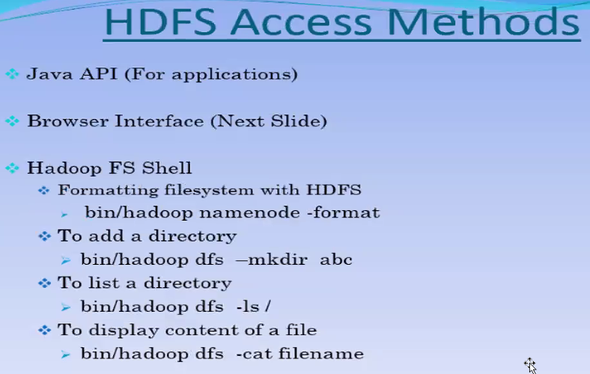

YARN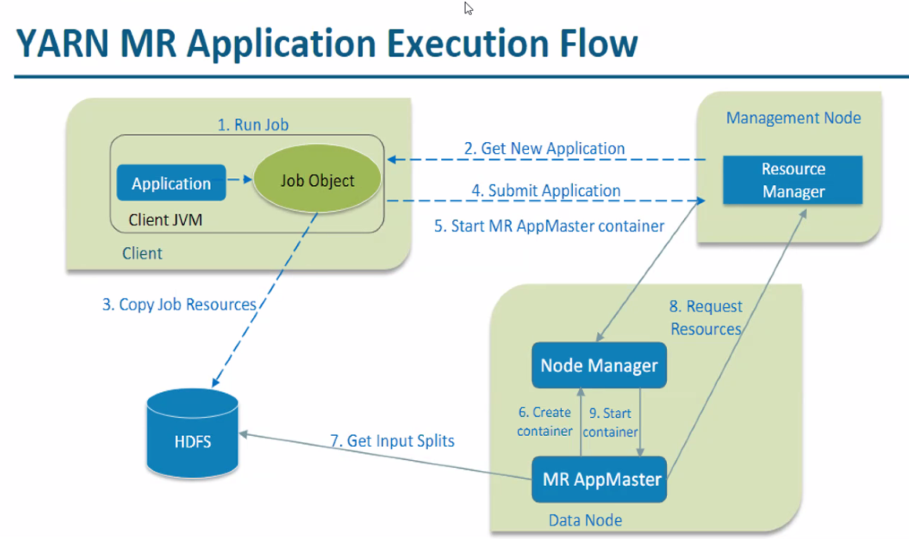

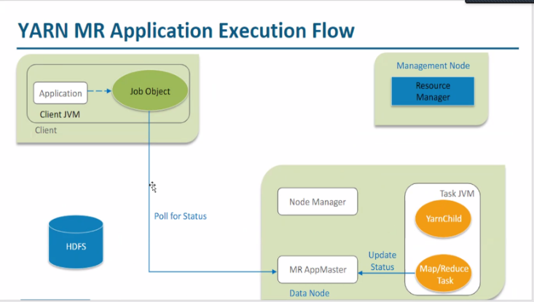

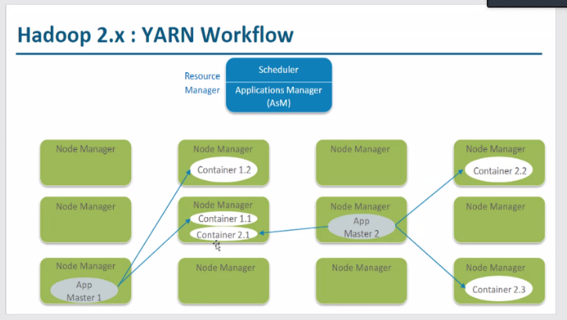

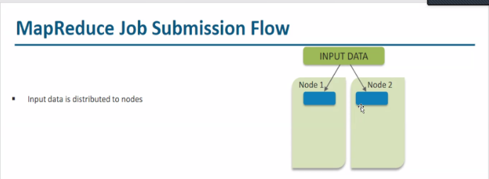

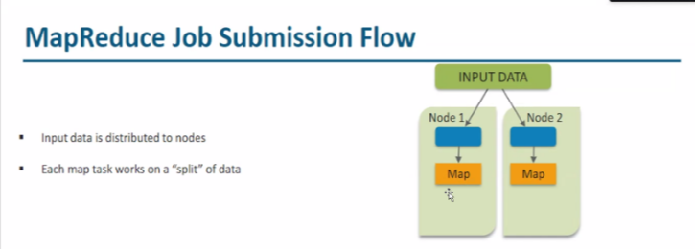

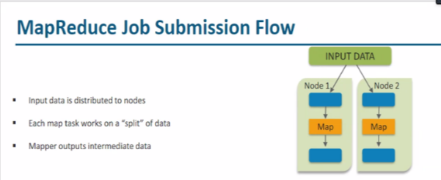

x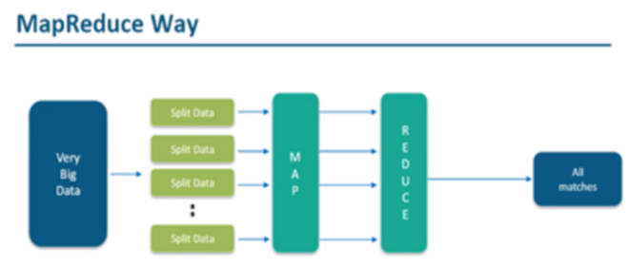

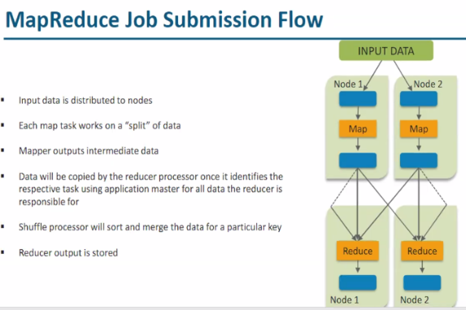

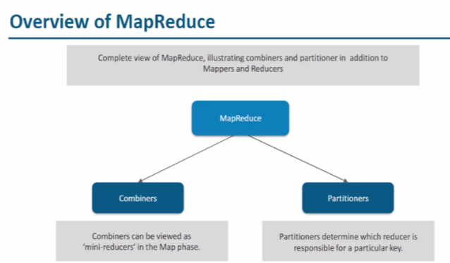

Types of NoSQL Data base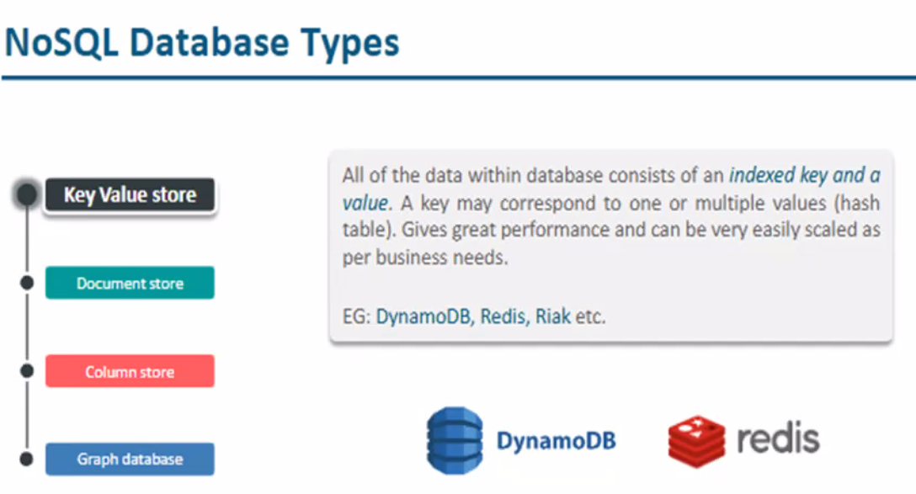

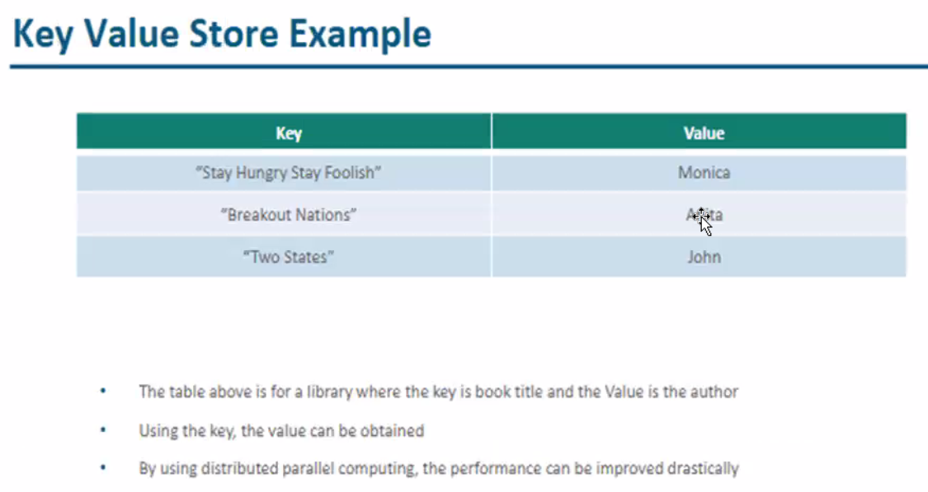

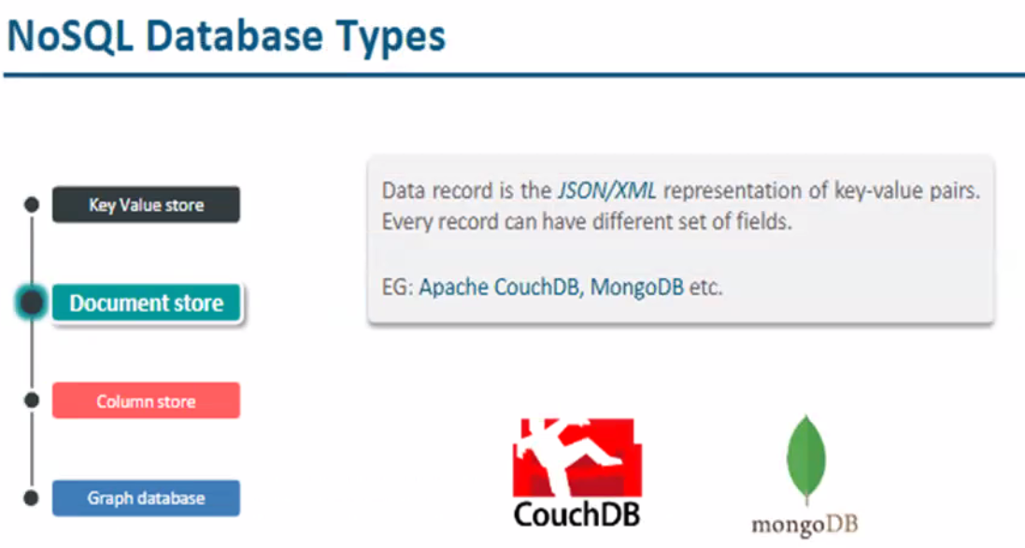

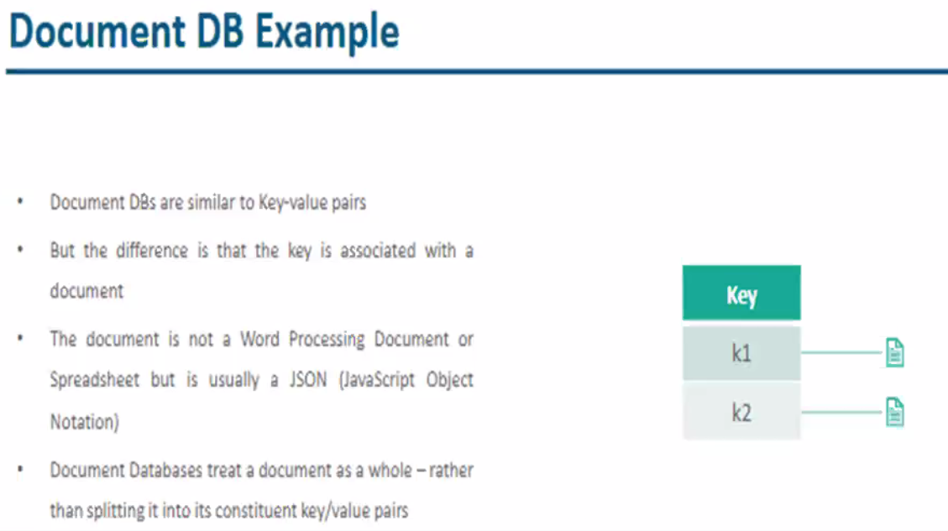

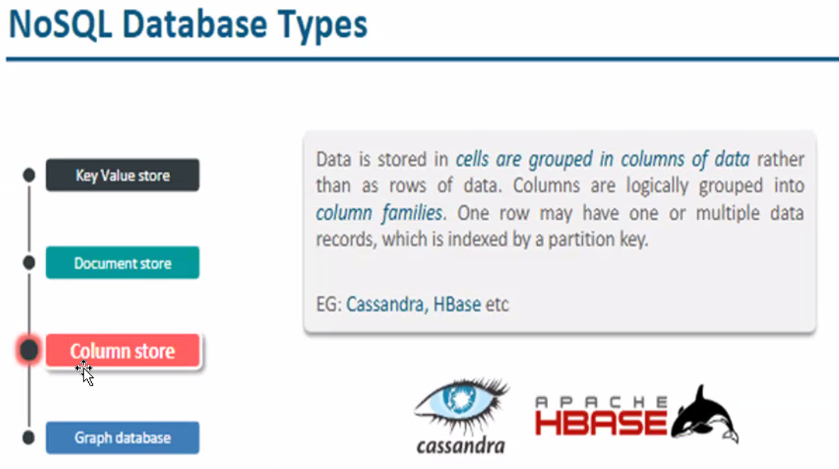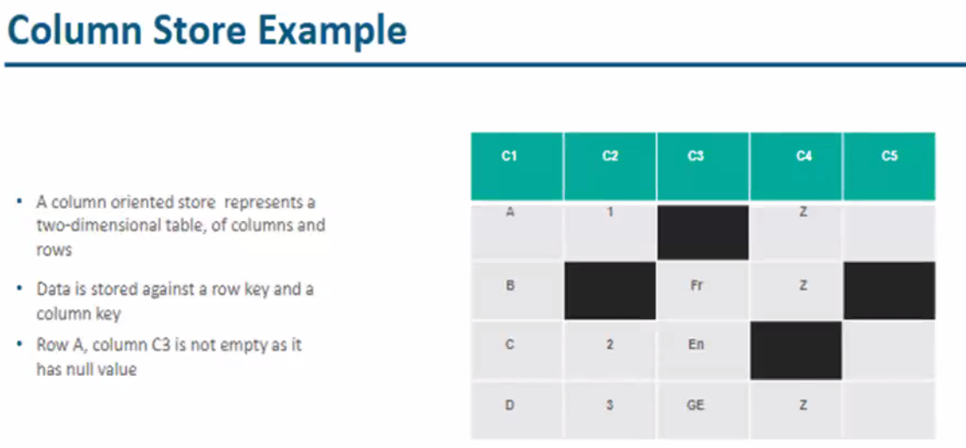

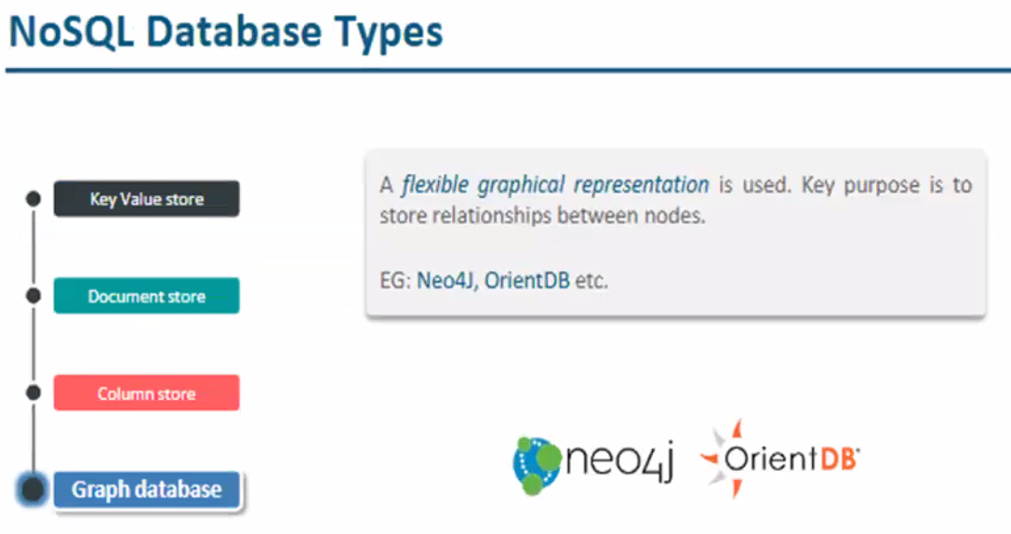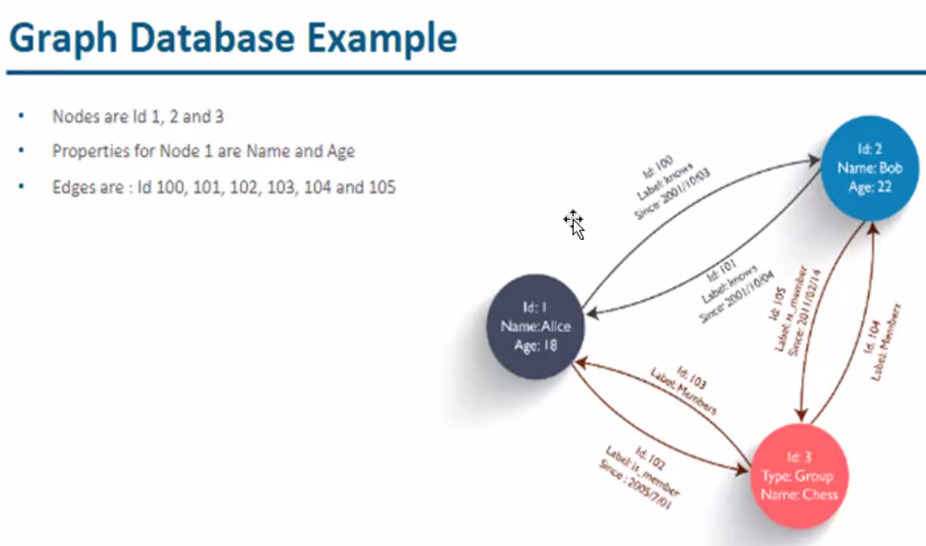

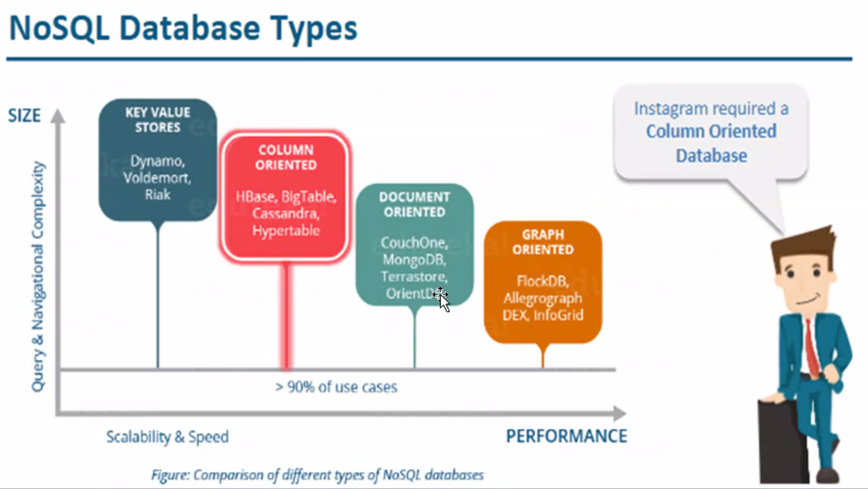



PRacticle

Hdfs dfs 🡪 will show all the list  
  
hdfs dfs -ls /

Hdfs dfs -mkdir /team2

vi text3.txt

Hdfs dfs -put test2.txt /team2

Hdfs dfs -copyFromLocal <loacal path> <destination Hadoop path>

Hdfs dfs -cp /Akshay/text1.txt /dest_dir

Hdfs dfs -cp -p /Akshay/text1.txt /dest_dir 🡪 taking ownership

Hdfs dfs -cp -f /Akshay/text1.txt /dest_dir 🡪 force copy

Hdfs dfs -mv /Akshay/text1.txt /dest_dir

Hdfs dfs -rm /Akshay/text1.txt

Hdfs dfs -get <source path from hadoop> <destination path from local)

Hdfs dfs -du /Akshay

Hdfs dfs -du -s /Akshay

bin/hdfs dfs  ----------check all hadoop commands

sbin/start-all.sh ---- start the Hadoop services  
jps ----Hadoop services are up and running  
bin/hdfs dfs -ls  <path> -----list all hdfs executables

Cretaing directory: In Hadoop dfs there is no home directory by default  
bin/hdfs dfs -mkdir <folder name>

creating home directory:

hdfs/bin -mkdir /user  
hdfs/bin -mkdir /user/username -> write the username of your computer

bin/hdfs dfs  -touchz  <file_path> ----creating file

copy:copy files/folders from hdfs store to local file system  
copyFromLocal--:  
bin/hdfs dfs -copyFromLocal <local file path>  <dest(present on hdfs)>  
bin/hdfs dfs -put ../Desktop/AI.txt /geeks

copyToLocal--:  
bin/hdfs dfs -copyToLocal  /mydir   ../Desktop/hero   
bin/hdfs dfs -get /mydir/myfile.txt  ../Desktop/hero

copy:copy files within hdfs  
bin/hdfs dfs -cp  <src(on hdfs)>  <dest(on hdfs)>

bin/hdfs dfs -cat <path> ---show content

move:move file from local to hdfs  
moveFromLocal--:  
bin/hdfs dfs -moveFromLocal <local src>   <dest(on hdfs)>   
bin/hdfs dfs -moveFromLocal  ../Desktop/cutAndPaste.txt   /mydir

move:move files within hdfs  
bin/hdfs dfs -mv  <src(on hdfs)> <src(on hdfs)>  
bin/hdfs dfs -mv  /mydir/myfile.txt  /mydir_copied

delete/remove:deletes a file from HDFS recursively  
It will delete all the content inside the directory then the directory itself.  
bin/hdfs dfs -rmr <filename/directoryName>

du :give the size of each file in directory  
bin/hdfs dfs -du  <dirName>

dus: give the total size of directory/file.  
bin/hdfs dfs -dus  <dirName>

stat:give the last modified time of directory or path  
bin/hdfs  dfs -stat    <hdfs file>

setrep: used to change the replication factor of a file/directory in HDFS.   
By default it is 3 for anything which is stored in HDFS (as set in hdfs core-site.xml)  
bin/hdfs dfs -setrep -R -w 6 myfile.txt  --changing to 6 for file  
bin/hdfs dfs -setrep -R -w 6 /mydir  --changing to 6 for directory

note: -w: wait till replication complete  
      -R:  recursive used for Directory mostly

**Hadoop Eco system**

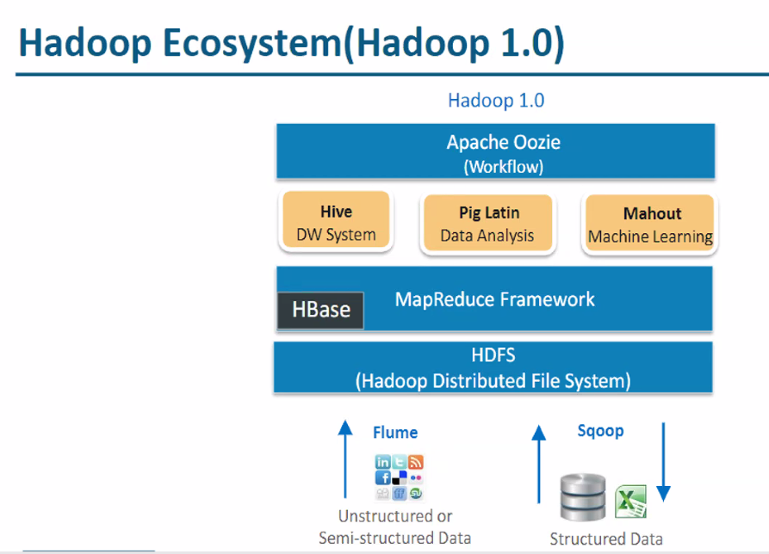

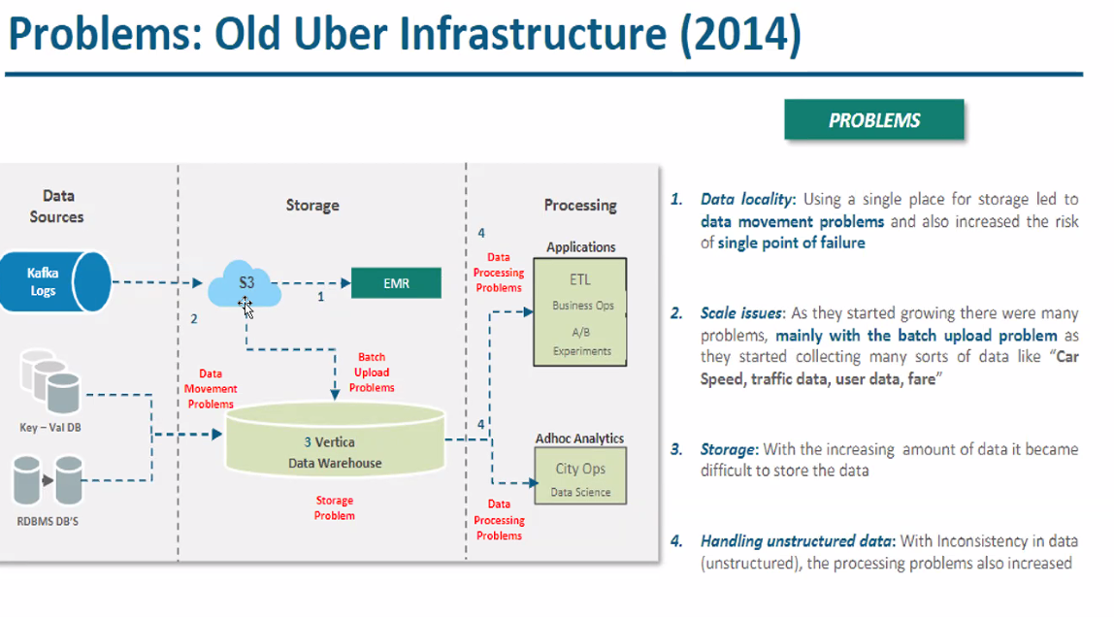

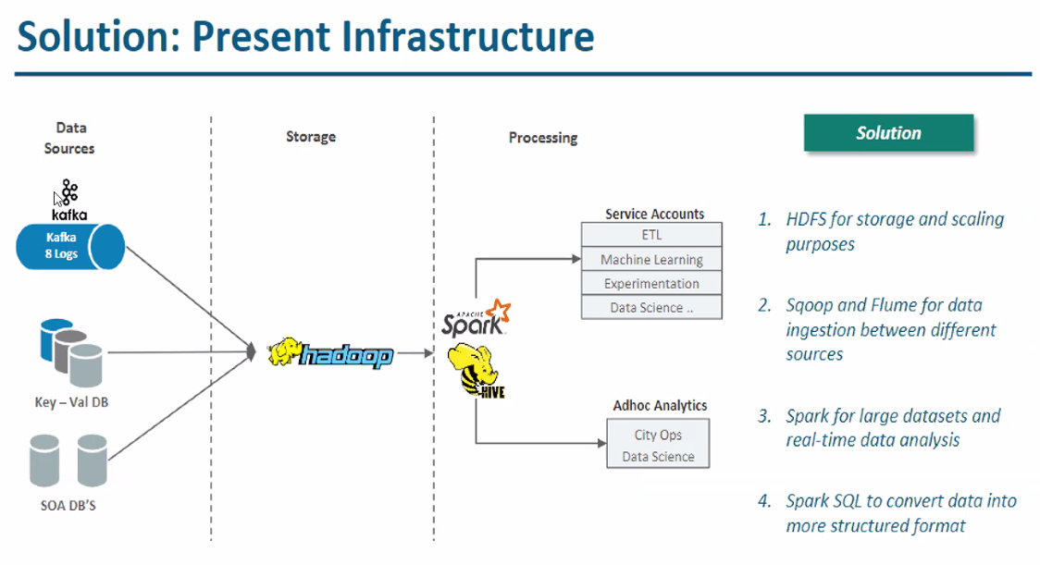

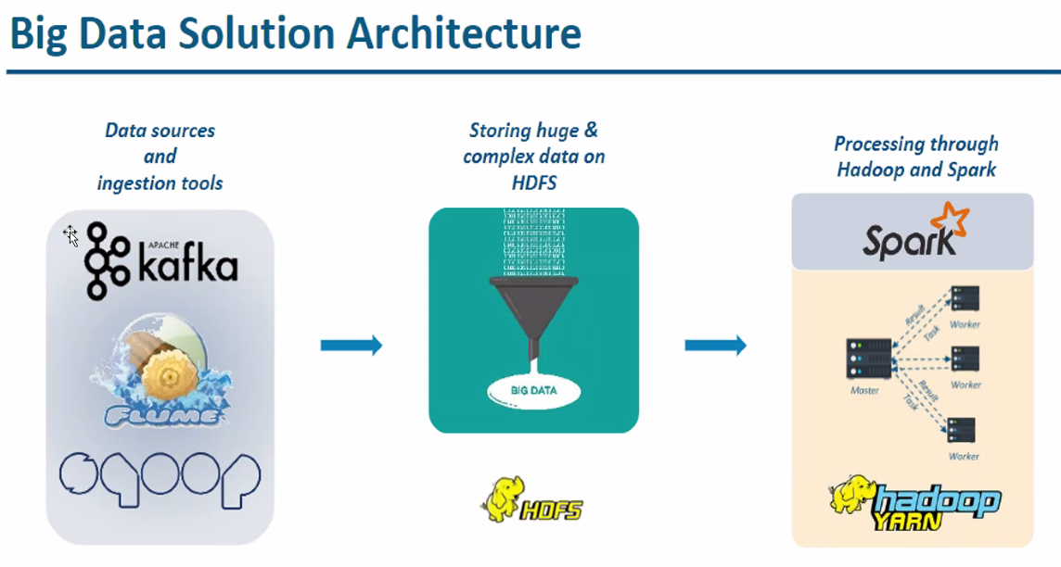

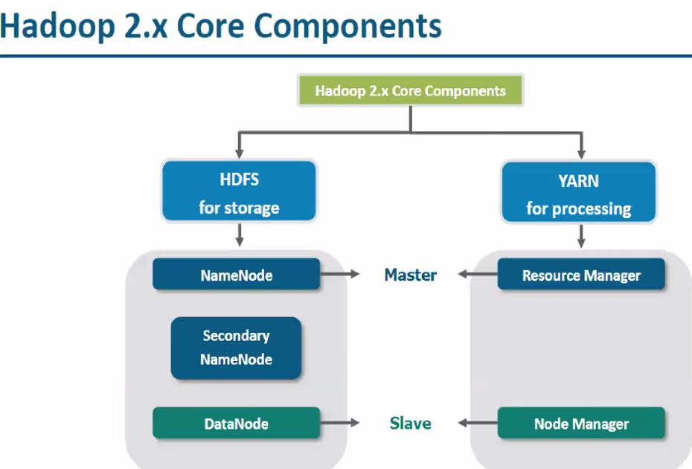

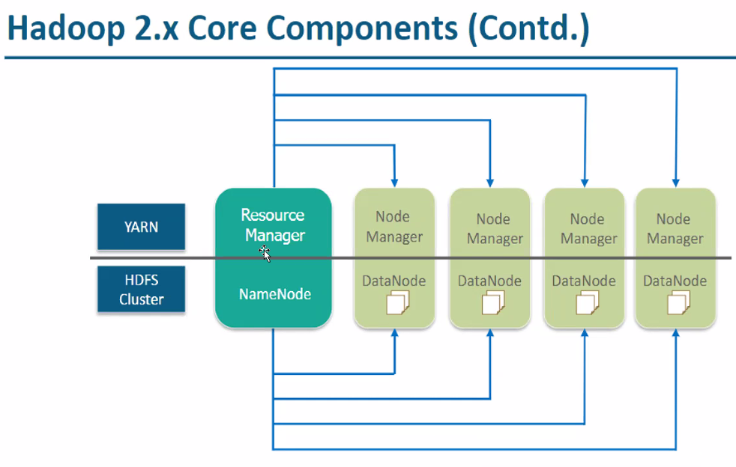

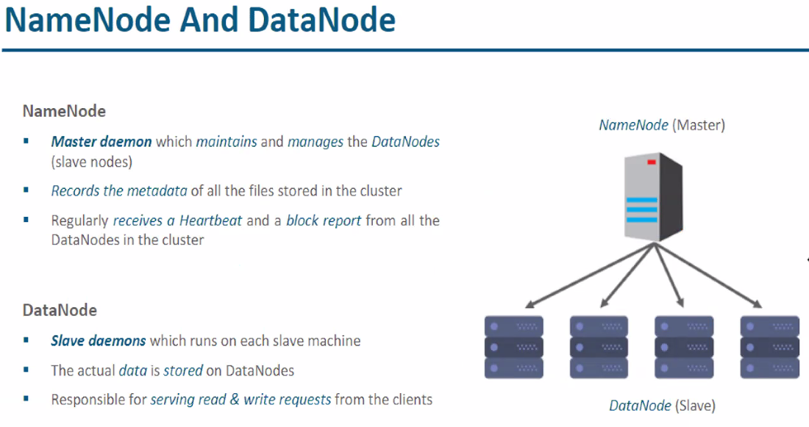

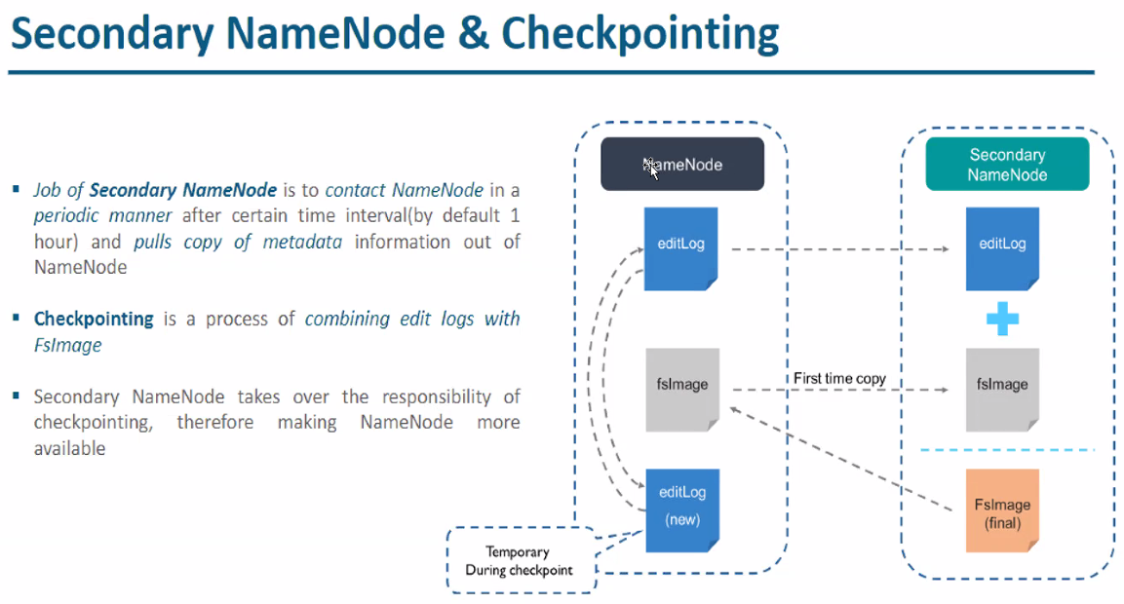

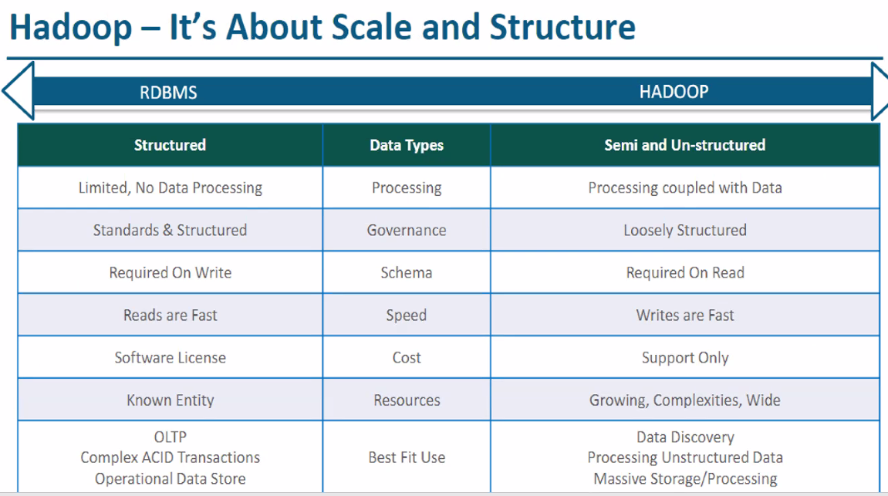

HBASE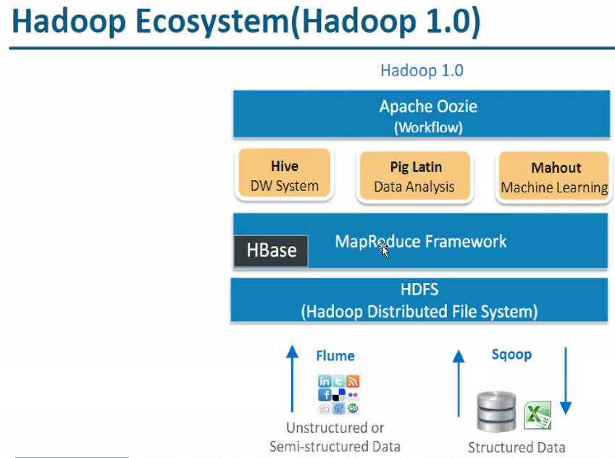

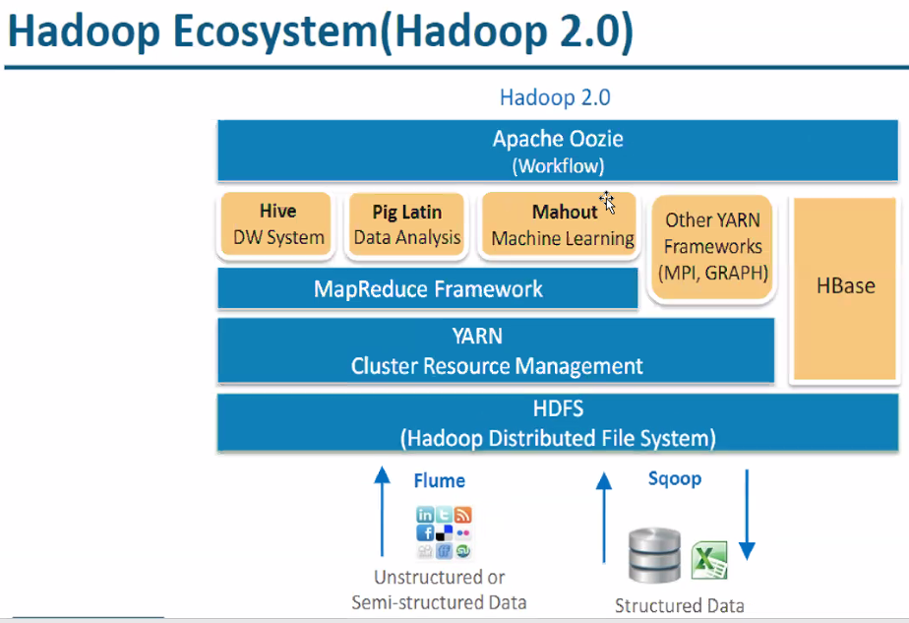

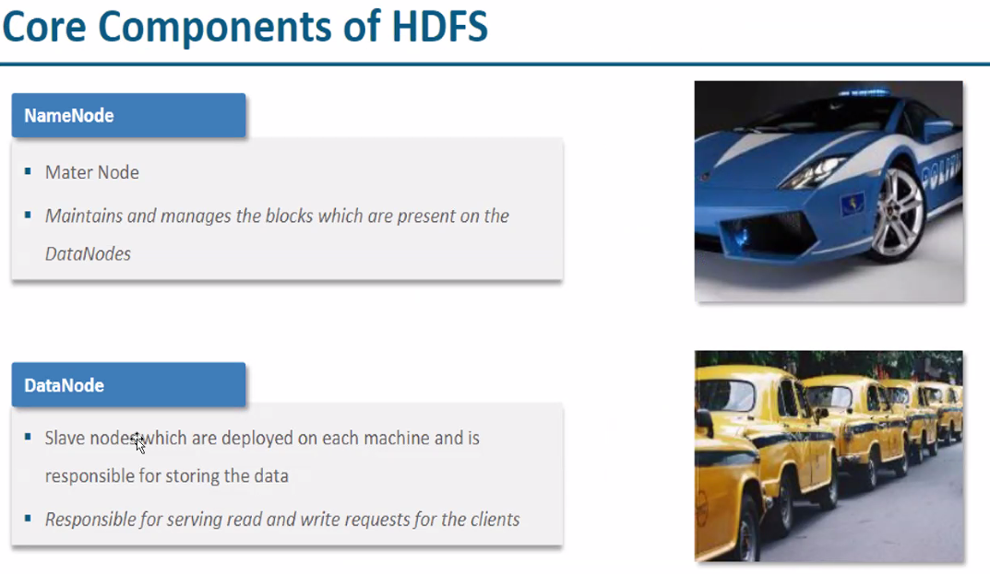

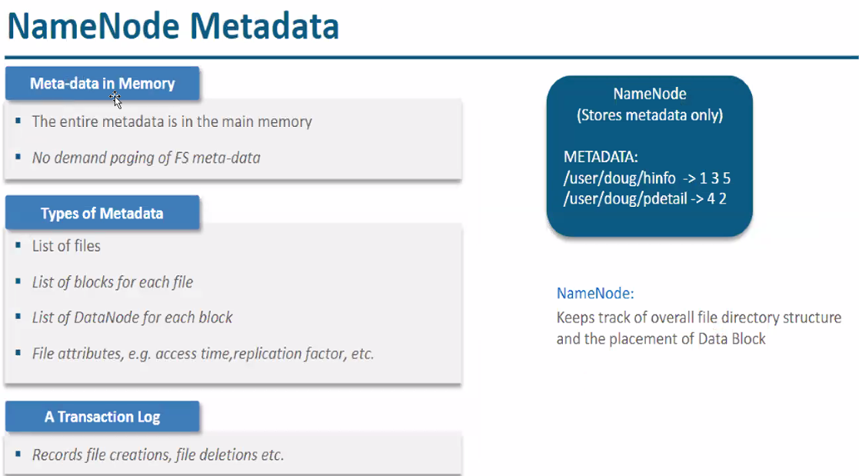

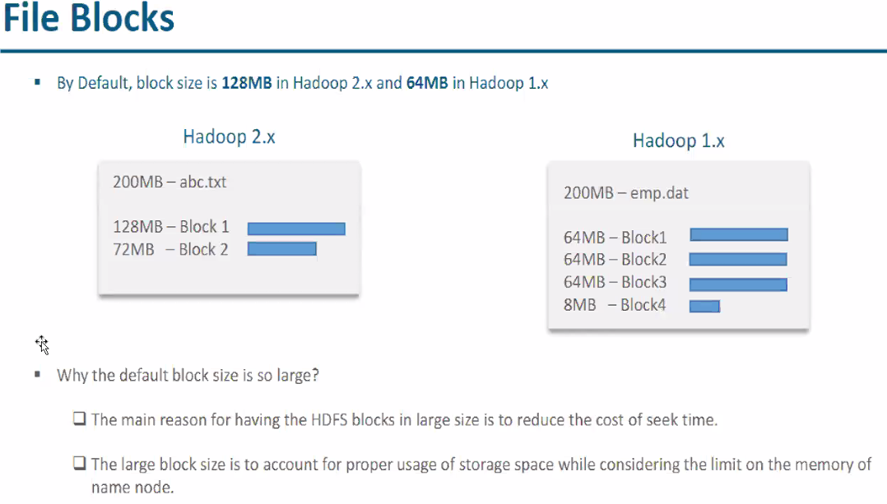

Hadoop read write mechanism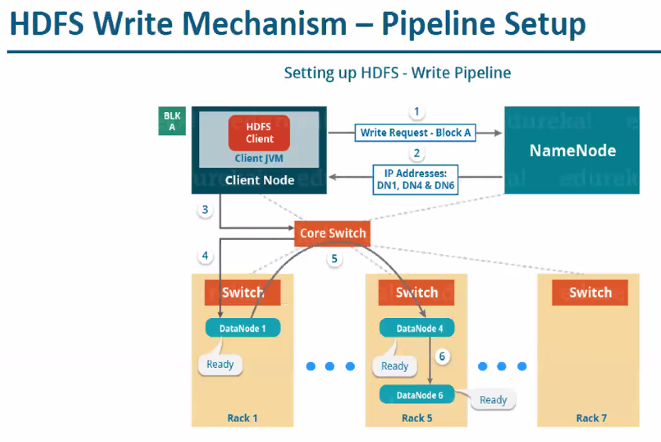

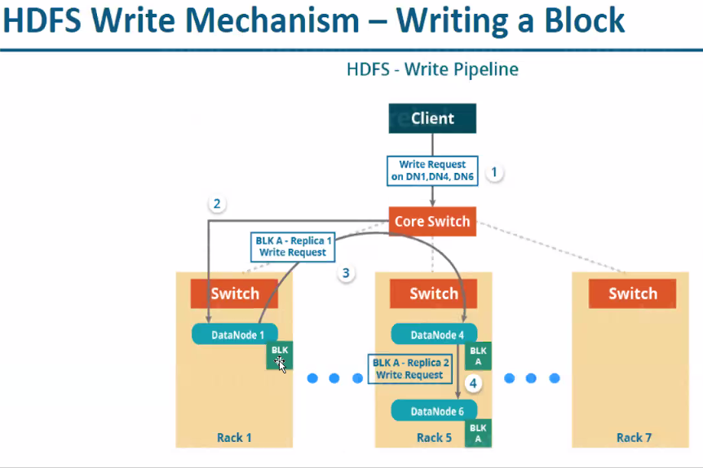

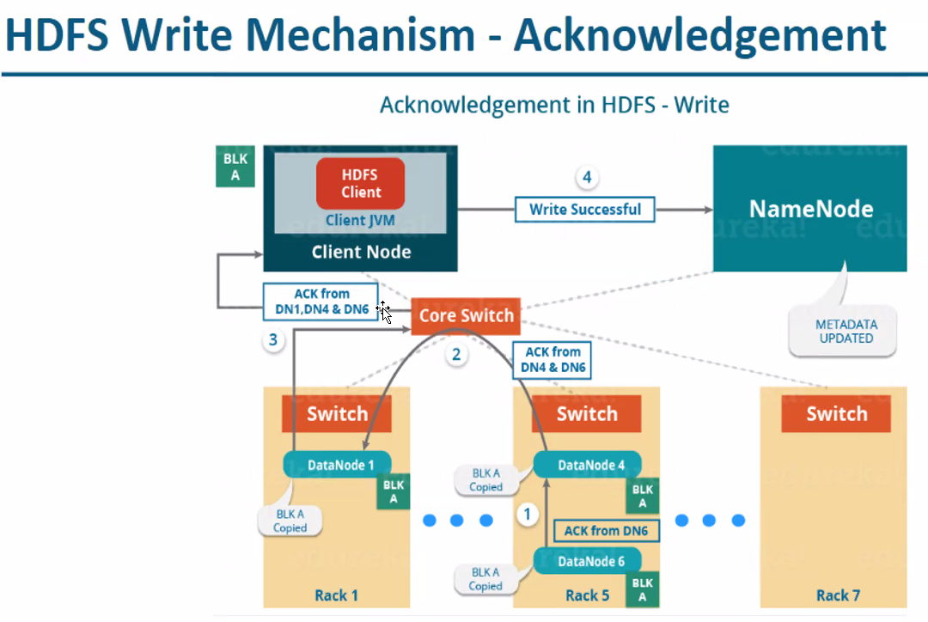

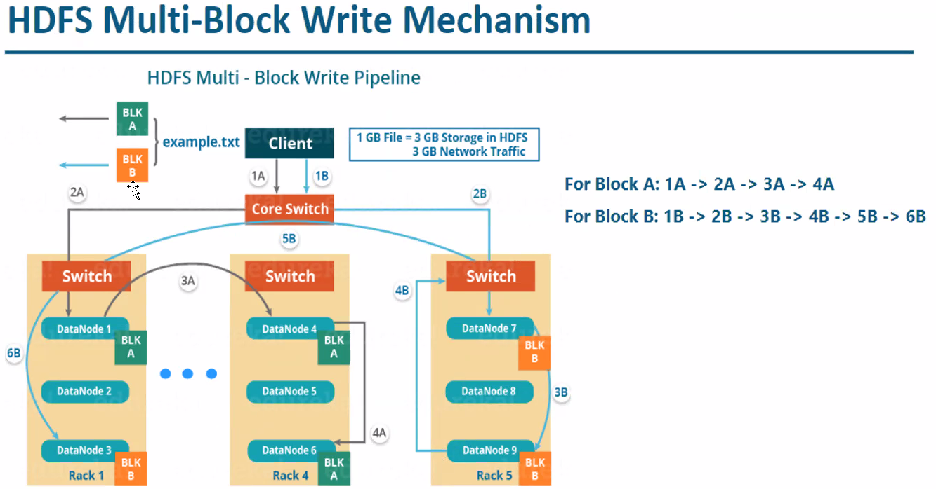

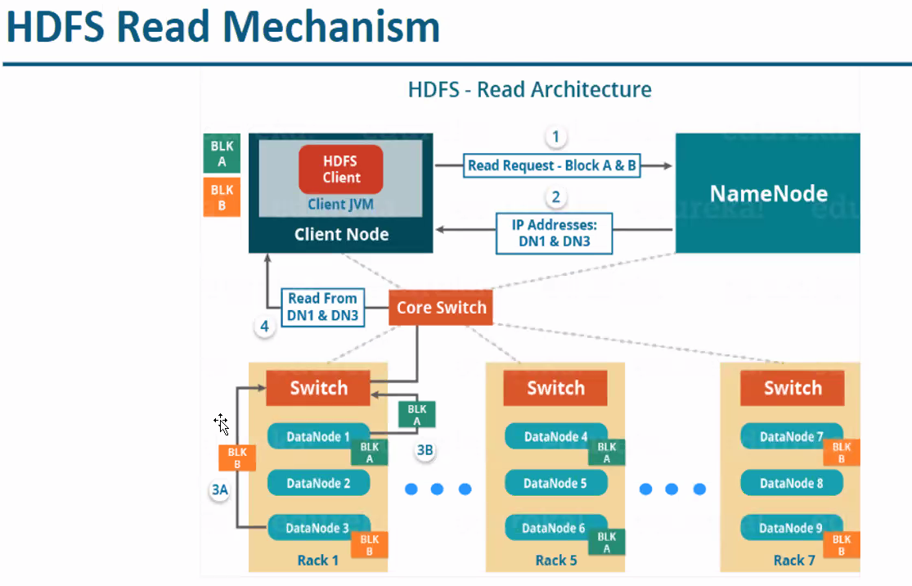

Hadoop Distrubuters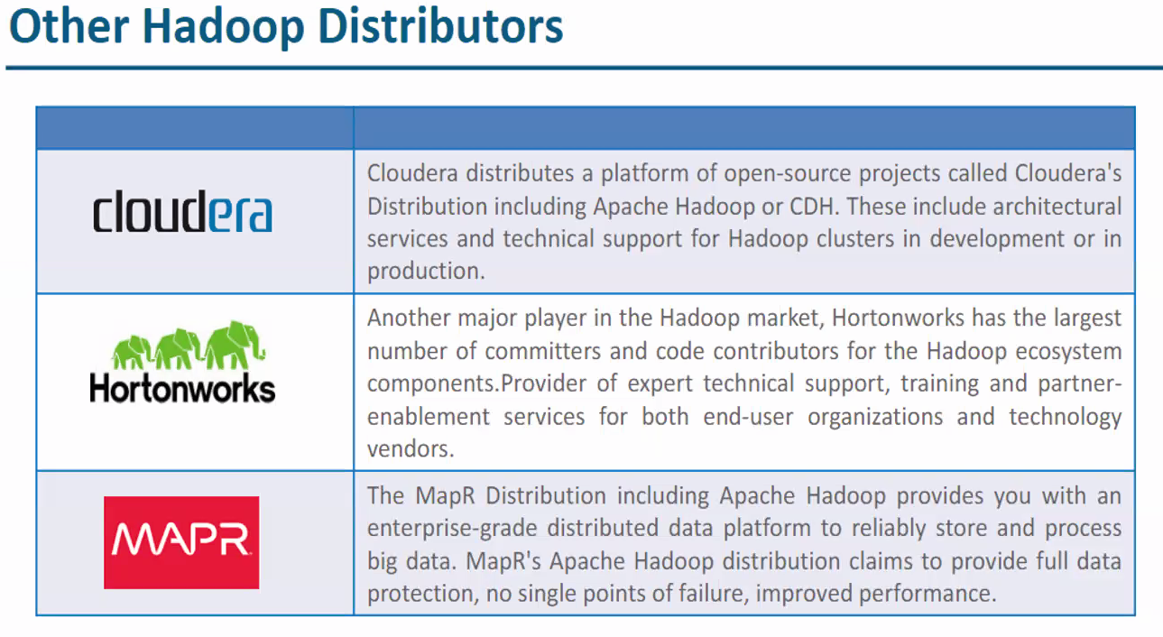

**HIVE**

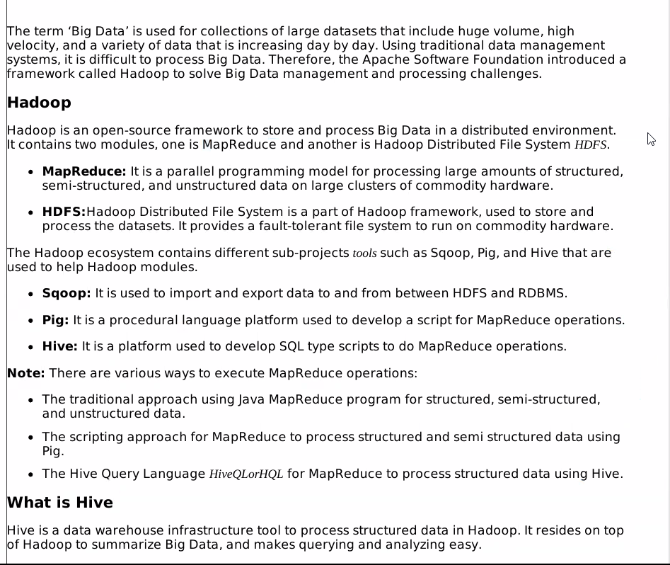

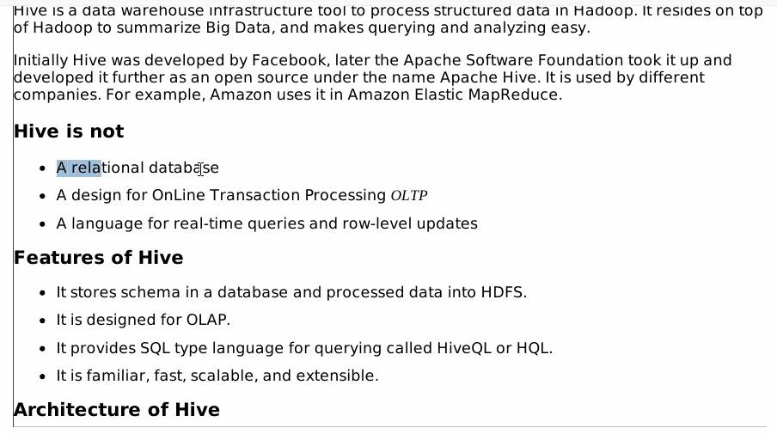

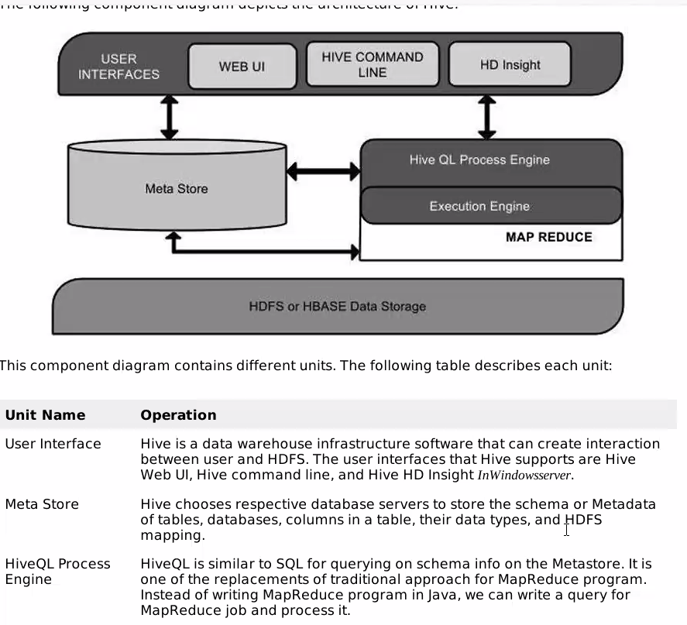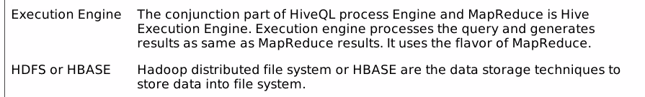

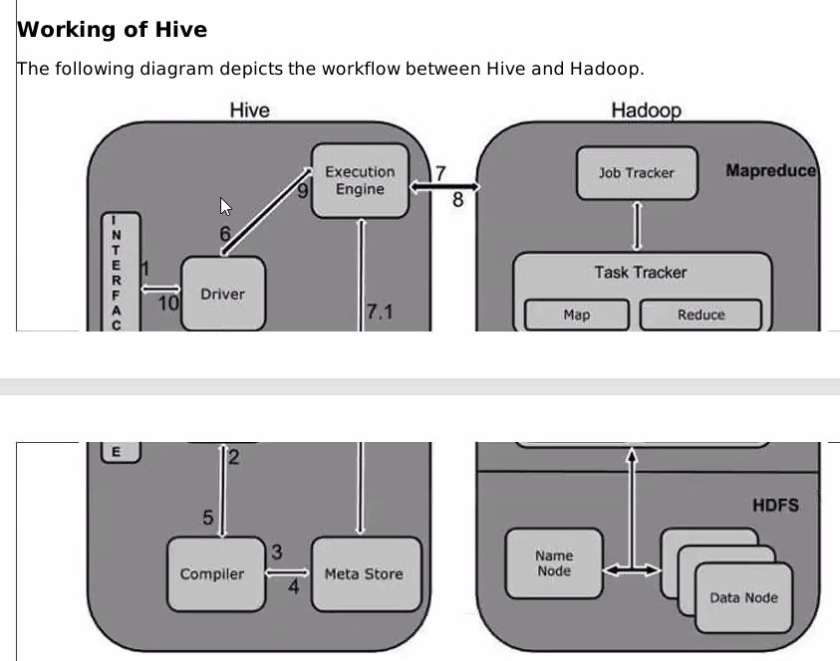

**Hive commands**

Hive 🡪 to enter into hive platform

Create table

Insert values 🡪 it run 3 jobs

Hbase shell 🡪 go to hbase platform

Pig 🡪 it will go to pig platform as grunt

Impala-shell 🡪 it will go to impala platform

**Hbase**

Hbase is a nosql database 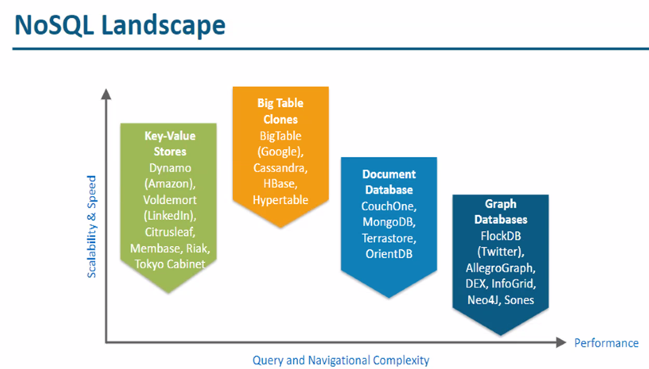

The **CAP theorem** is a fundamental principle in distributed database systems. It stands for **Consistency, Availability, and Partition Tolerance**. According to the CAP theorem, a distributed system can only guarantee two out of these three properties at any given time:

1. **Consistency**: Every read receives the most recent write or an error. This means all nodes in the system have the same data at the same time.
2. **Availability**: Every request (read or write) receives a response, even if some nodes are down.
3. **Partition Tolerance**: The system continues to operate despite network partitions that separate nodes into isolated groups.

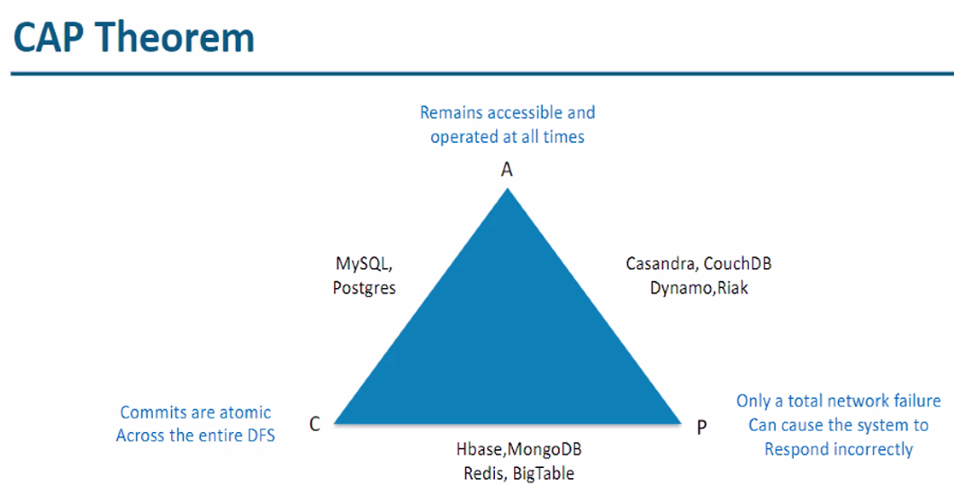

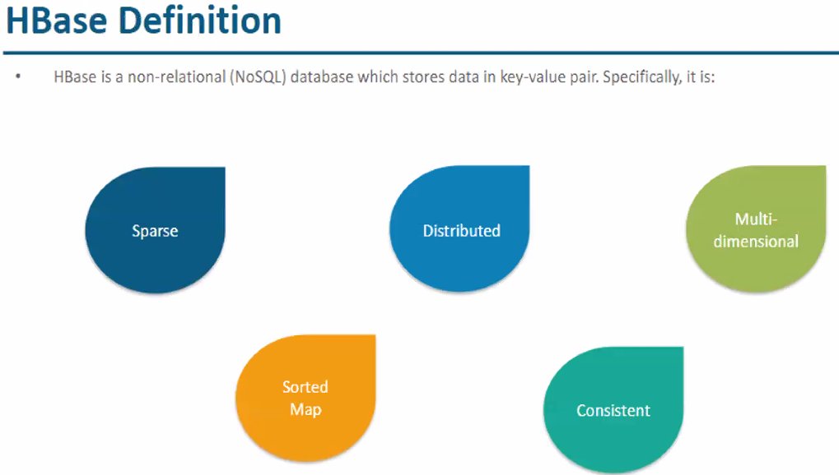

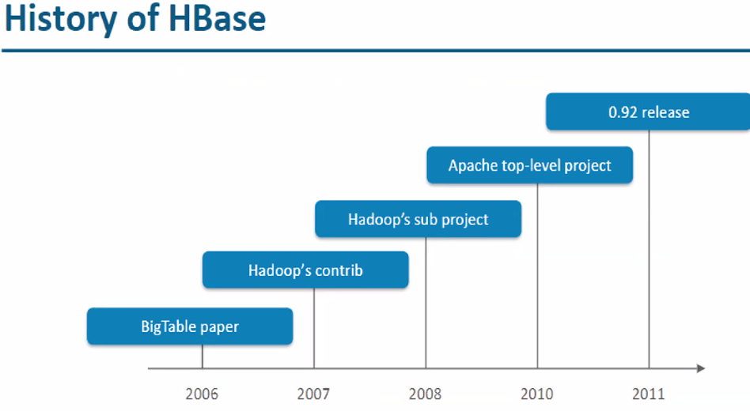

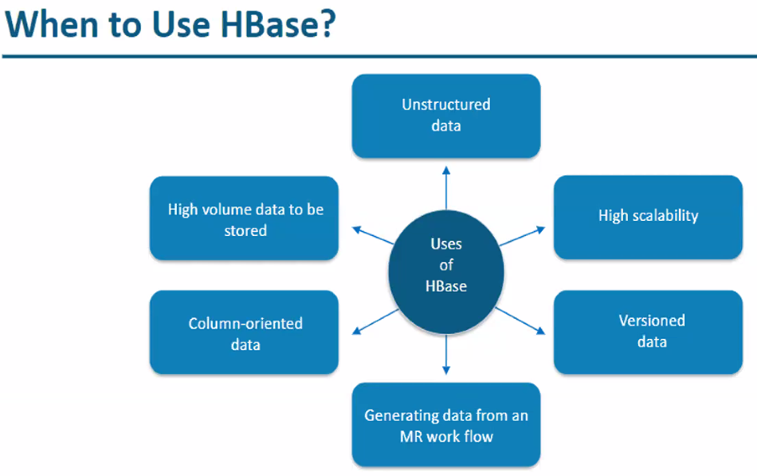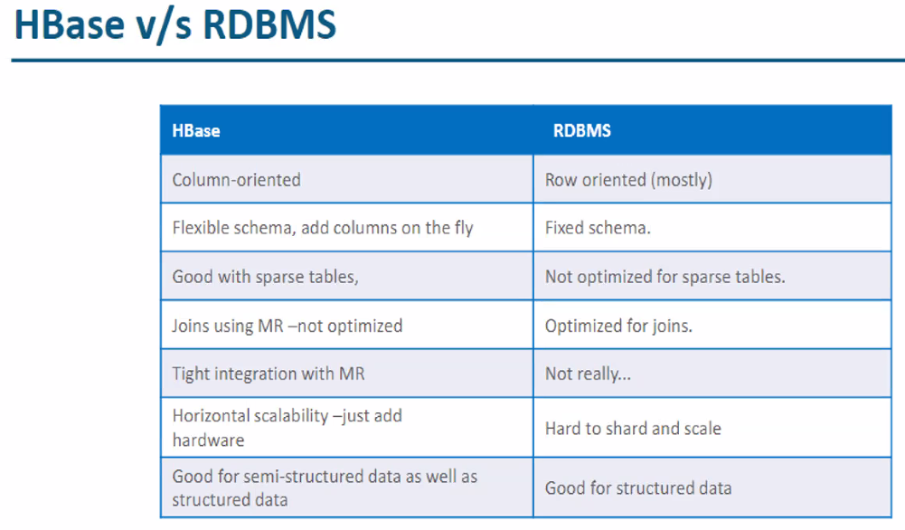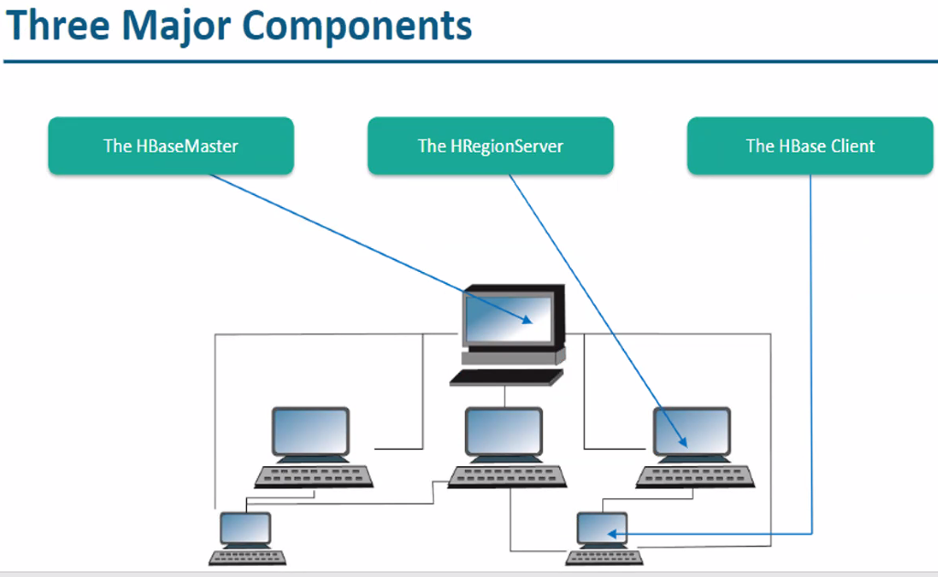

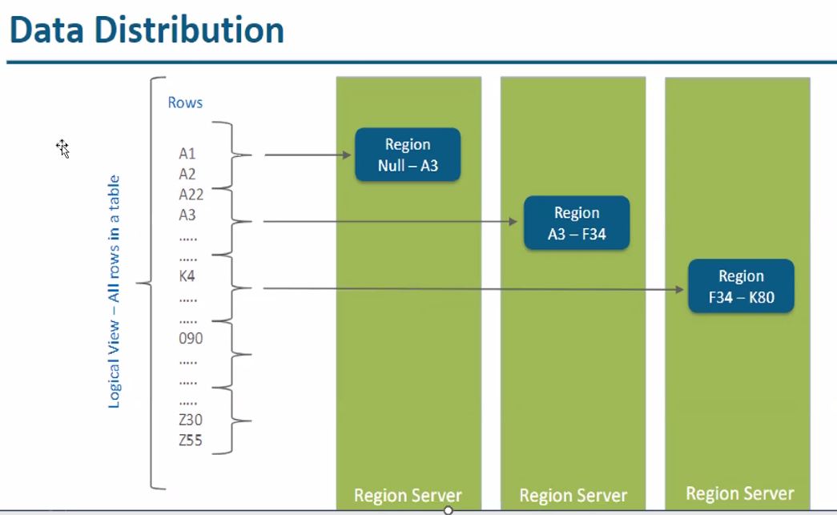

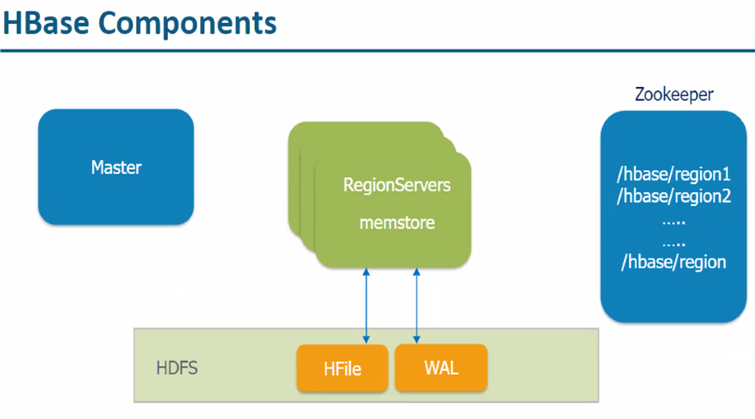

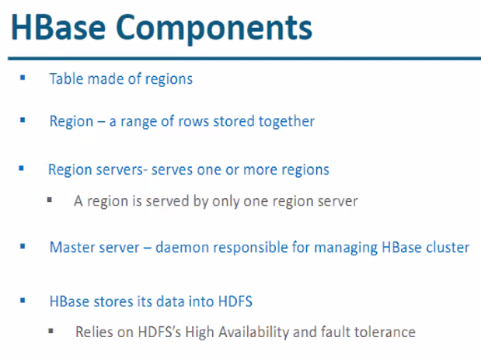

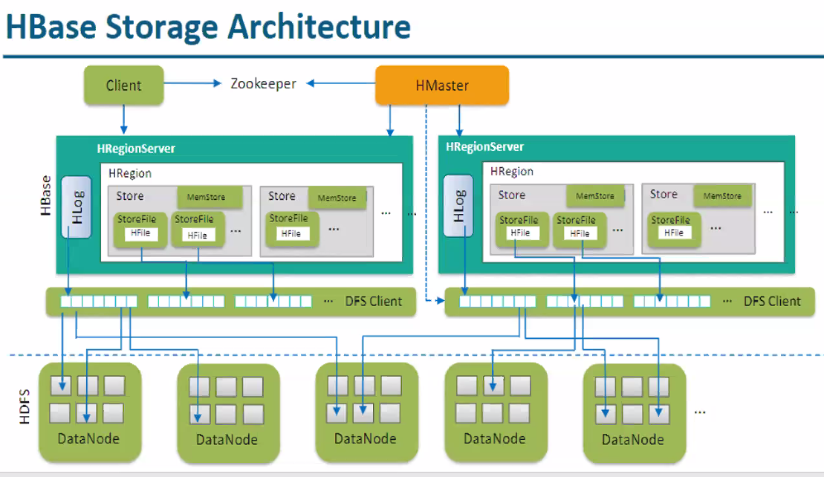

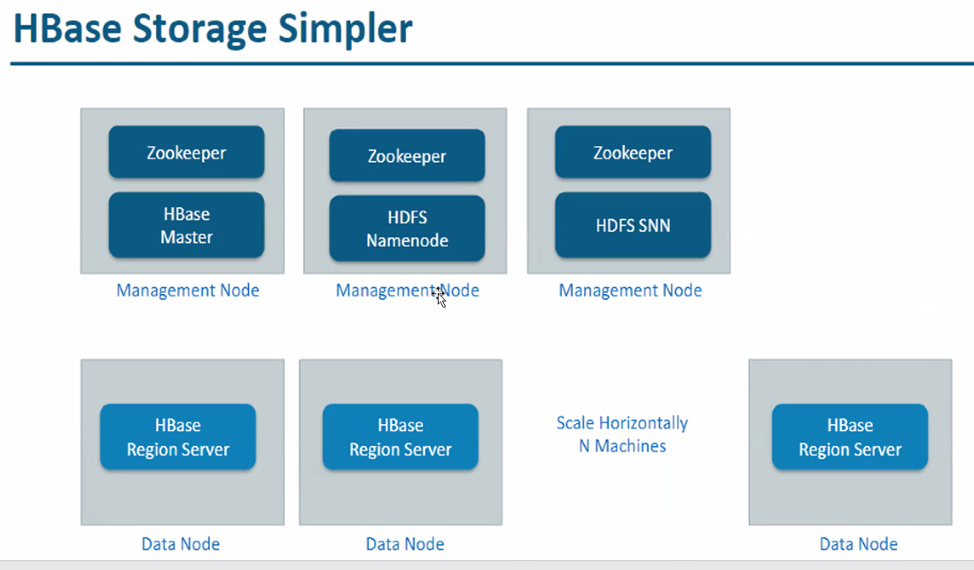

Hbase read and write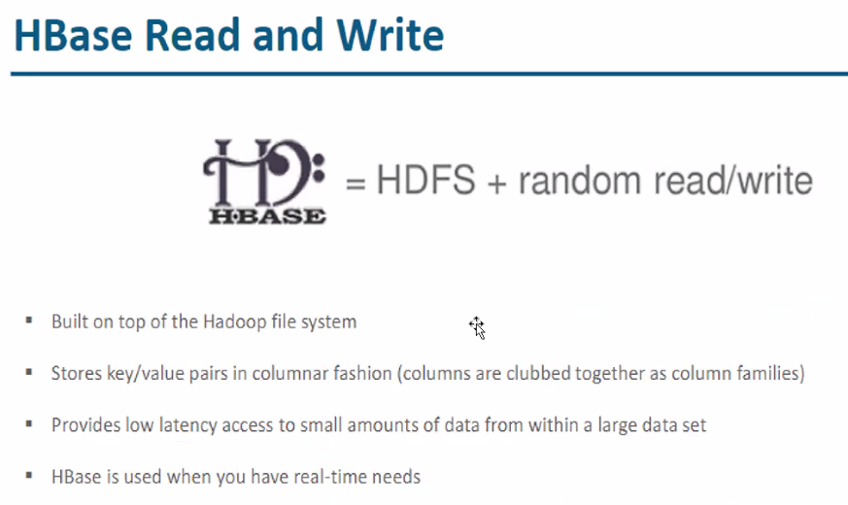

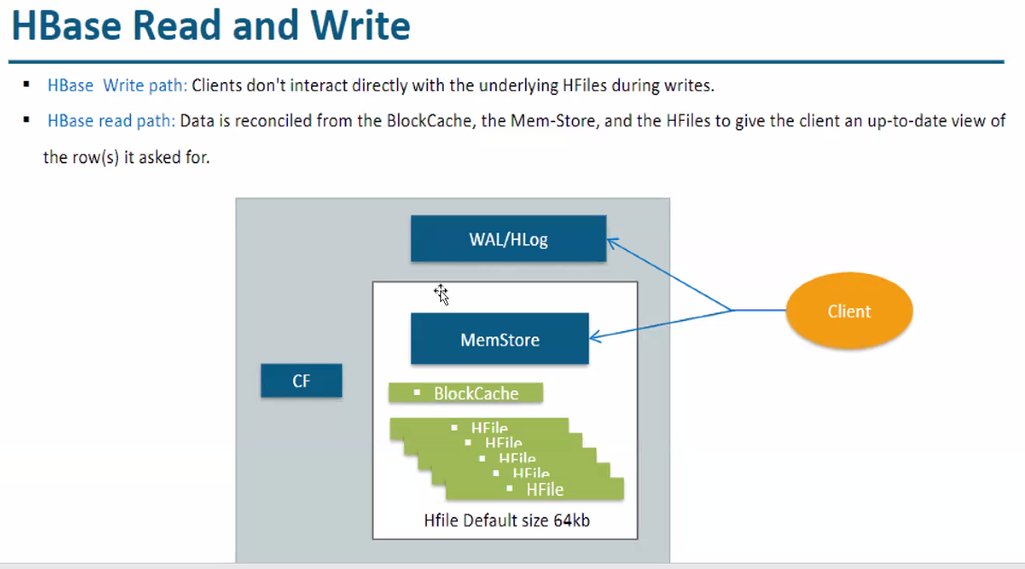

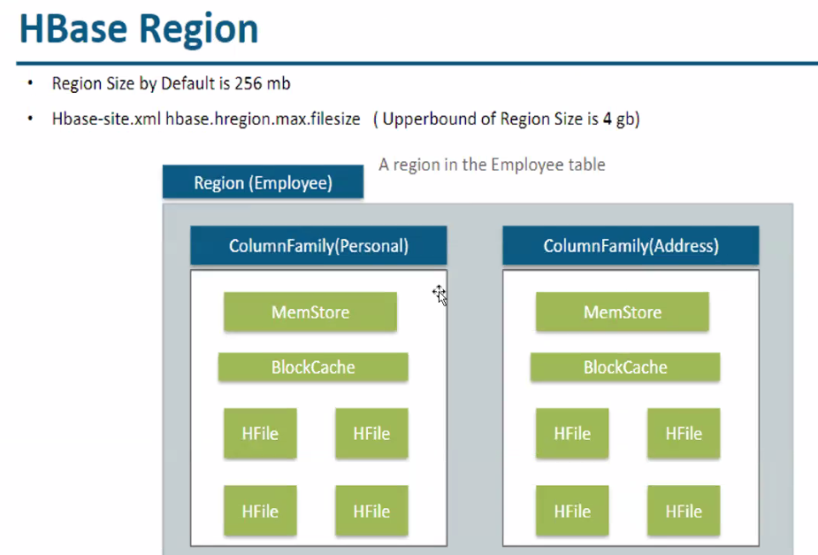

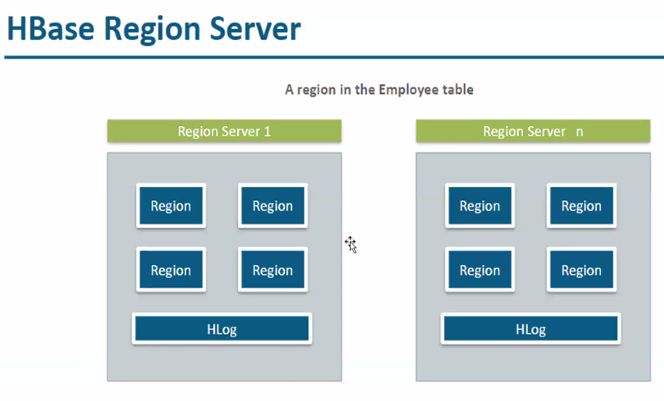

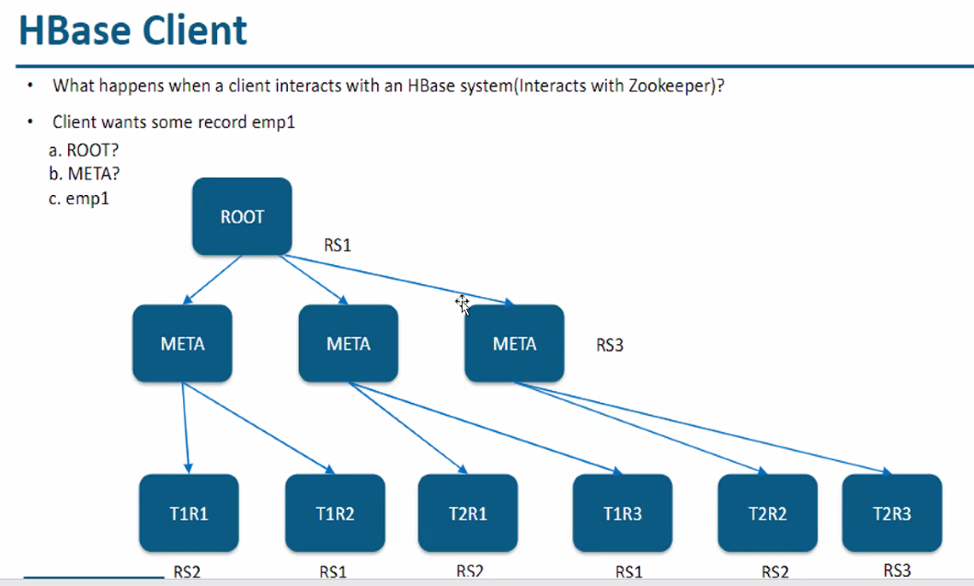

Hbase commands

* Hbase shell 🡪 to goto hbase platform
* To insert values